**Azure API Management LAB**

(How to create an API, Deploy to Azure, Manage Using Azure API Management and use in client-application.)

1. Create a Web API (ASP.NET WEB API)
2. Publish this Web API to an Azure web app (Host/deploy services to Azure)
3. Publish to Azure Management API(Manage services using Azure API Management)
4. Use API in client project.

## **Pre-requisite**

* Visual Studio 2015
* A valid Windows Azure subscription.
* Basic knowledge of ASP.NET WEB API
* Basic knowledge of Restful services

1. **Create a Web API (Create an ASP.NET WEB API)**

**Step 1:** Open visual studio and create a new project, File->New->Project.

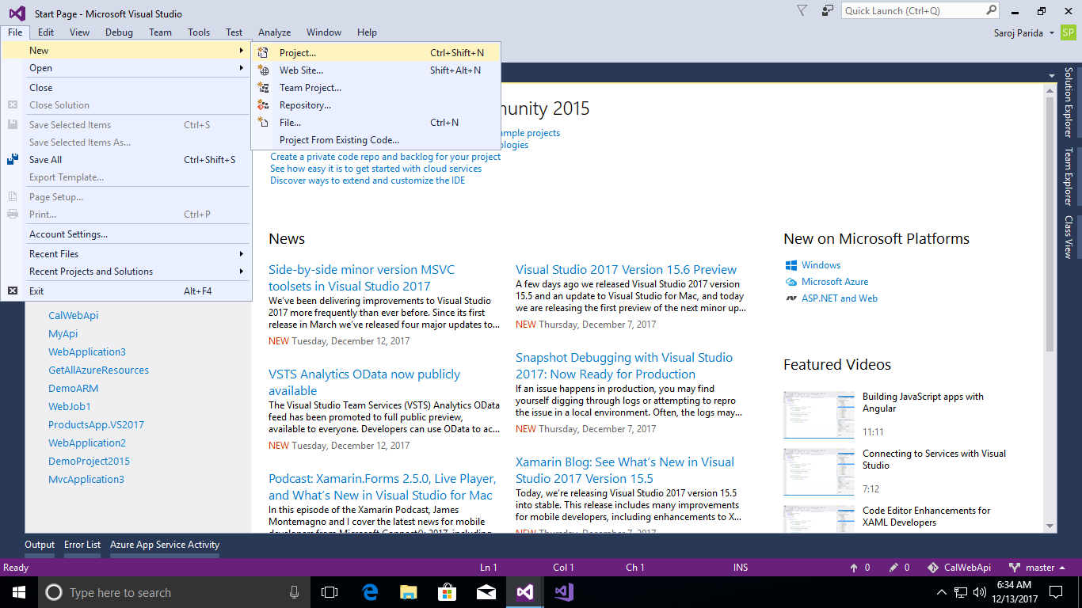

**Step 2:** Select Web in left panel and Asp.Net web Application. Then enter the application name (Ex: CalDemo)

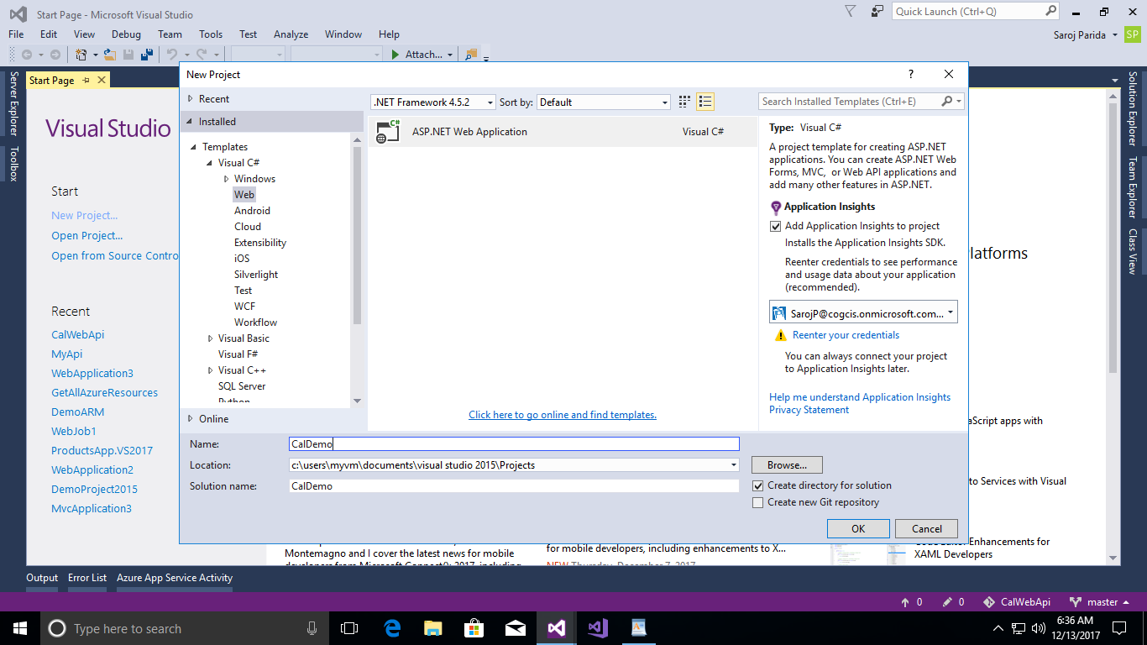

**Step 3:** Select ‘Web API’ and click OK.

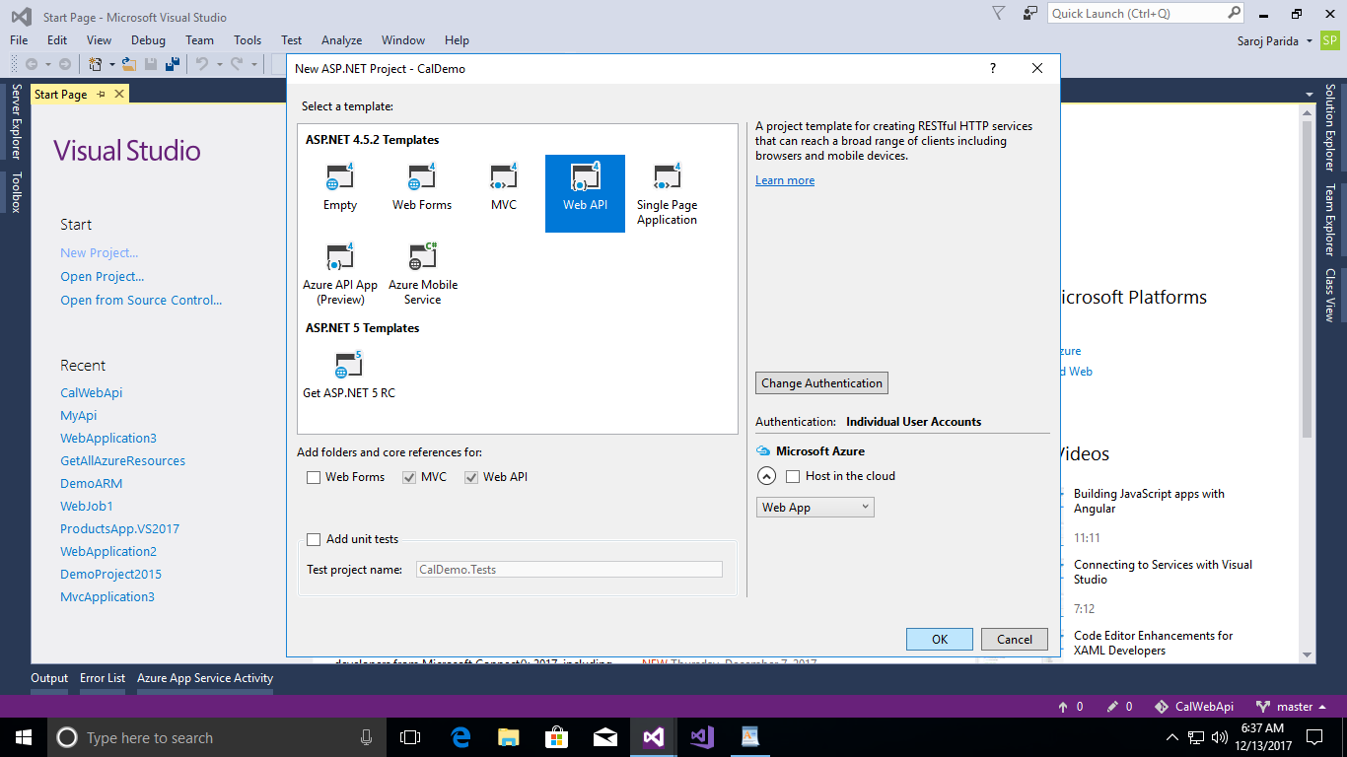

**Step 4:** Now it has been created a ‘wep api’ with default settings.

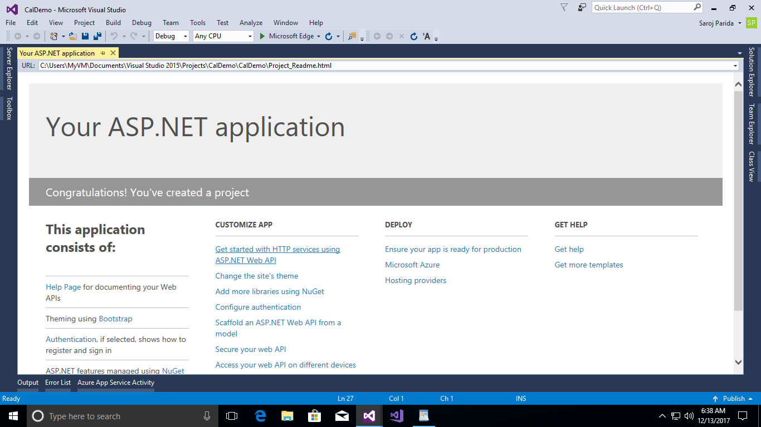

**Step 5:** Create a new controller “***MathController***”. Controllers->Add->Controller.

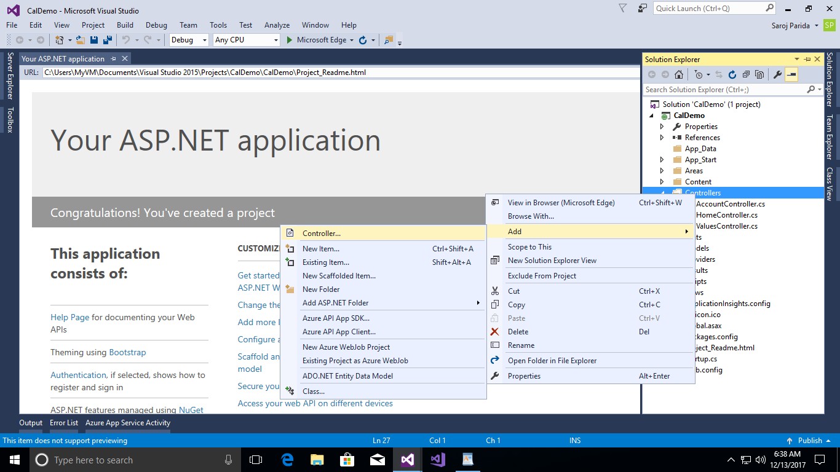

**Step 6:** Select Web API 2 Controller – Empty.

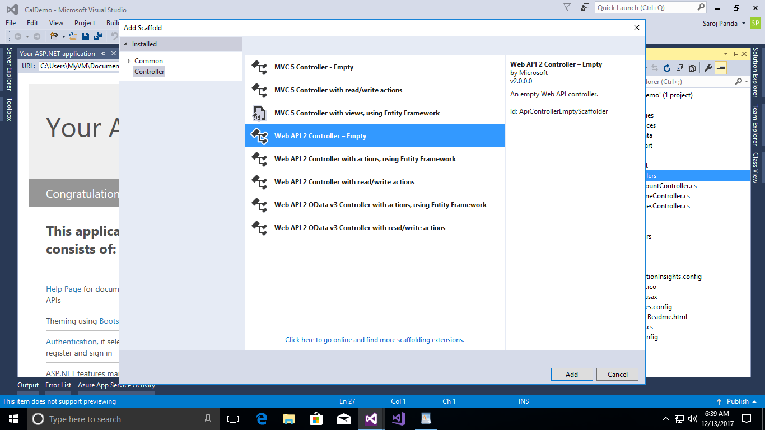

**Step 7:** Enter Controller name along with controller, no space between controller name and controller (Ex: MathController)

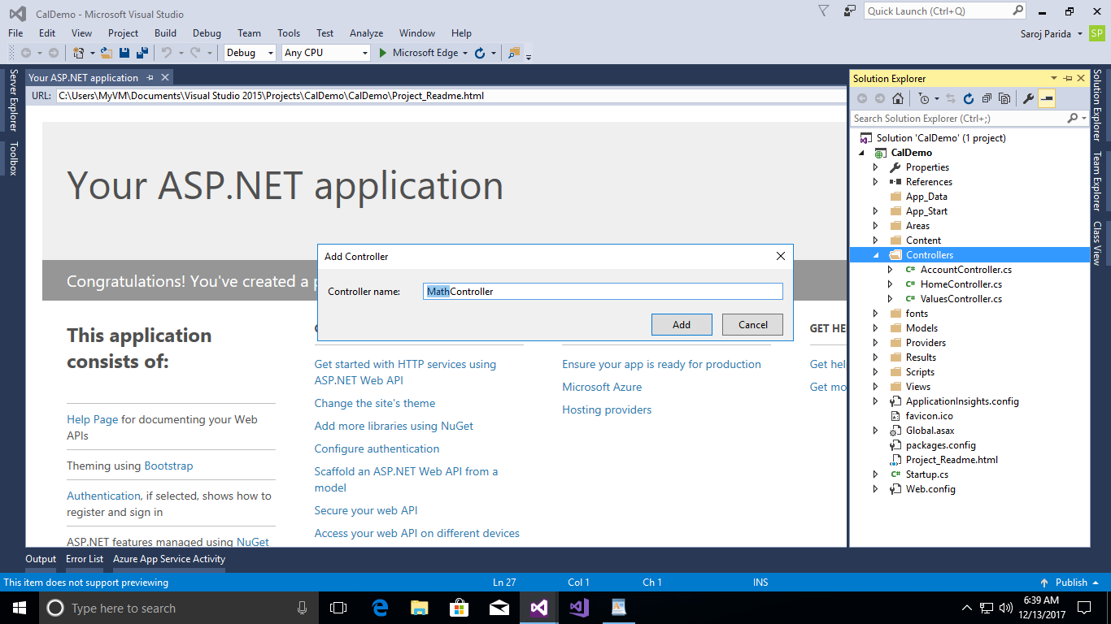

**Step 8:** It will create a blank controller with default code like below screen shot.

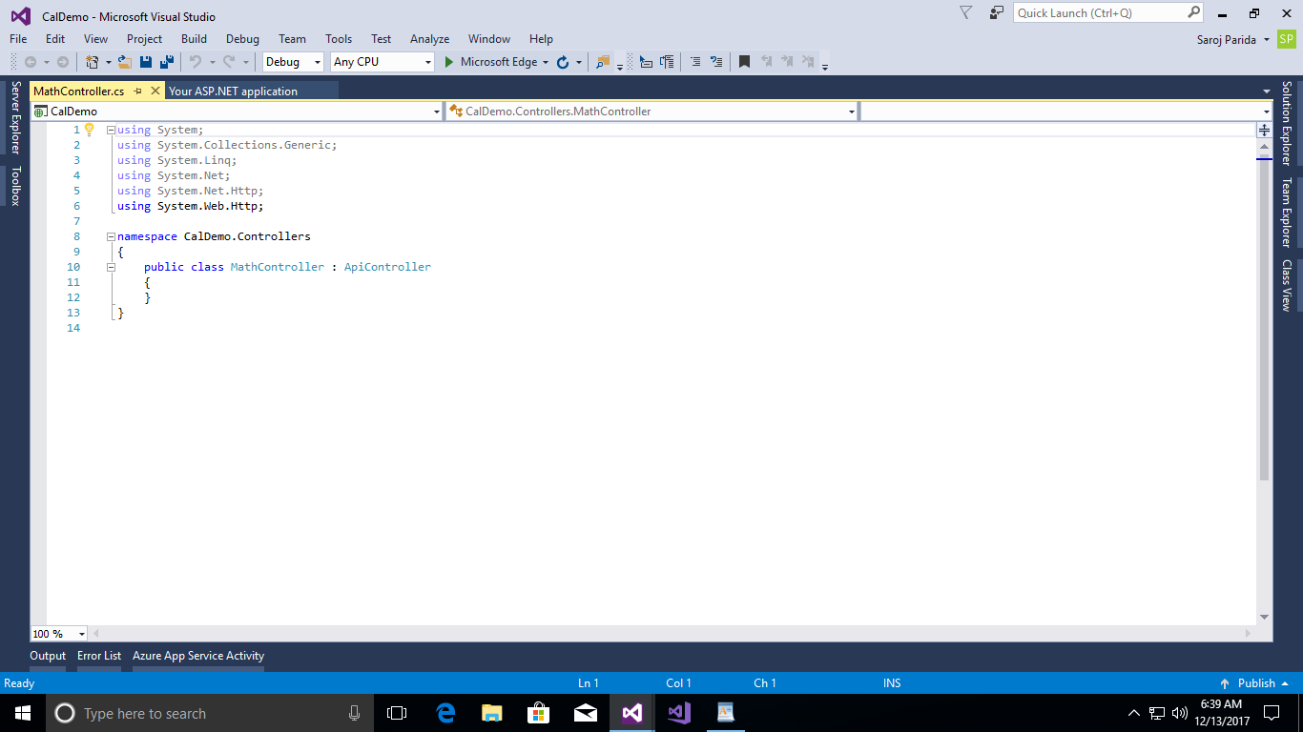

**Step 9:** Use below codes in MathController.

using System;

using System.Collections.Generic;

using System.Linq;

using System.Net;

using System.Net.Http;

using System.Web.Http;

namespace CalDemo.Controllers

{

public class MathController : ApiController

{

[HttpGet]

public int Add(int value1, int value2)

{

return value1 + value2;

}

[HttpGet]

public int Substract(int value1, int value2)

{

return value1 - value2;

}

[HttpGet]

public int Multiply(int value1, int value2)

{

return value1 * value2;

}

[HttpGet]

public int Divide(int value1, int value2)

{

return value1 / value2;

}

[HttpGet]

public string Get()

{

return "default";

}

}

}

**Step 10:** Comment all the code in “AccountController” and “ValuesController” or remove it. It will looks like below screen shot.

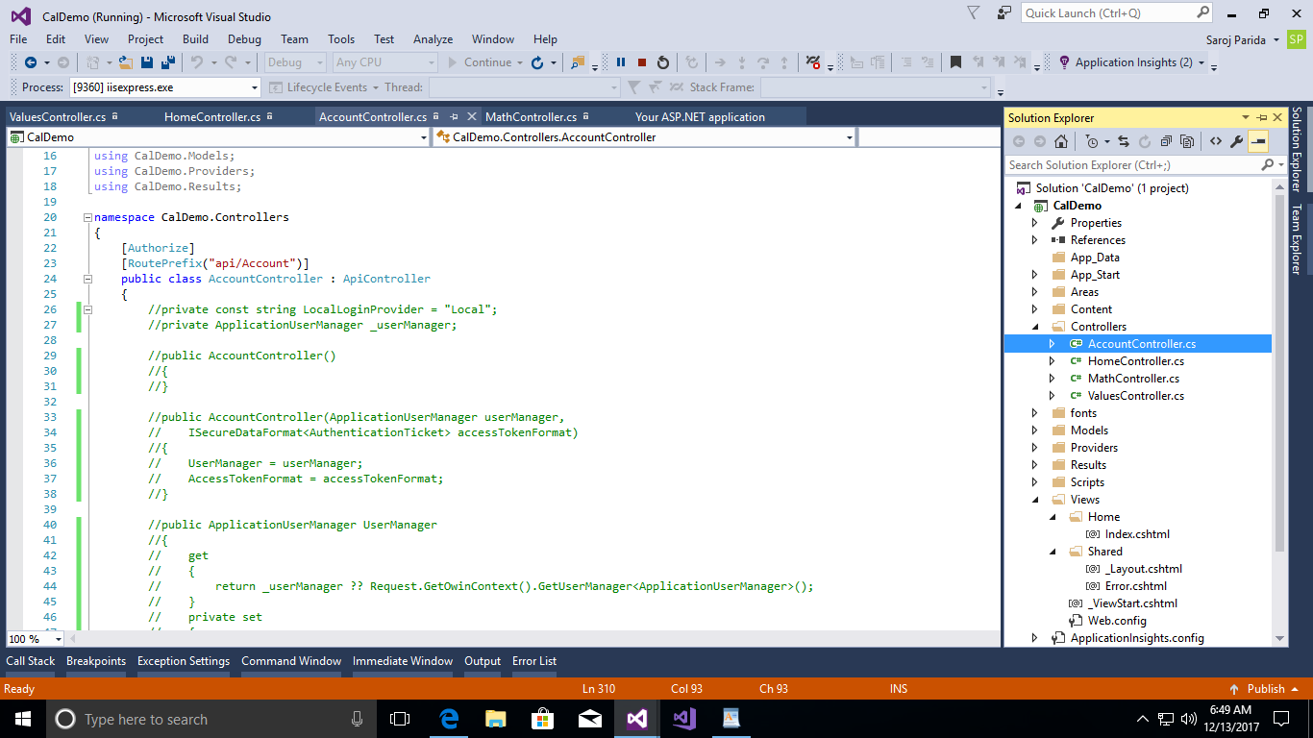

**Step 11:** Save all and run the application (F5)

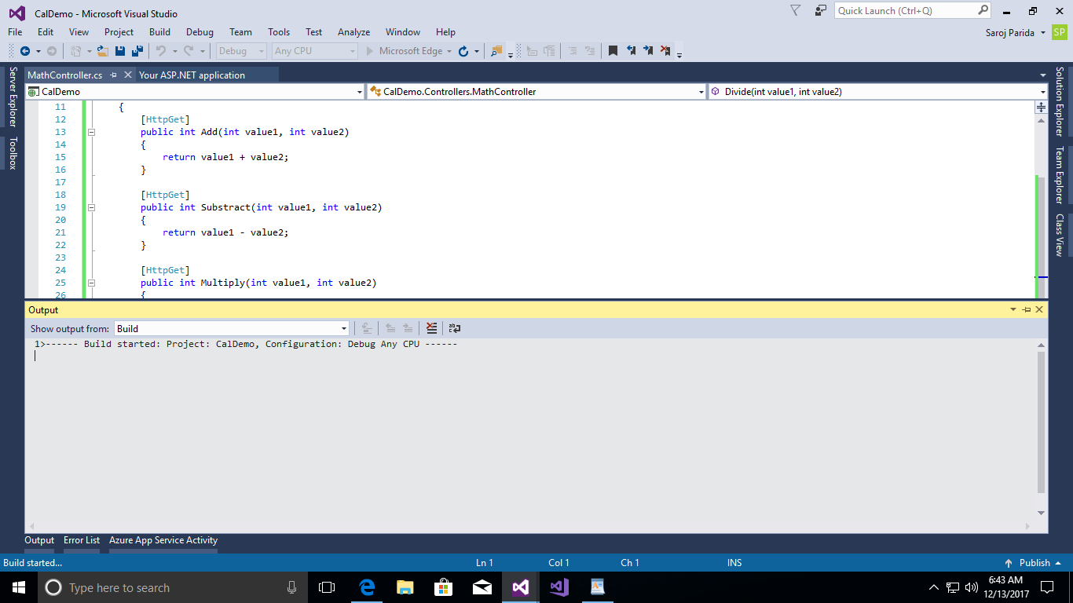

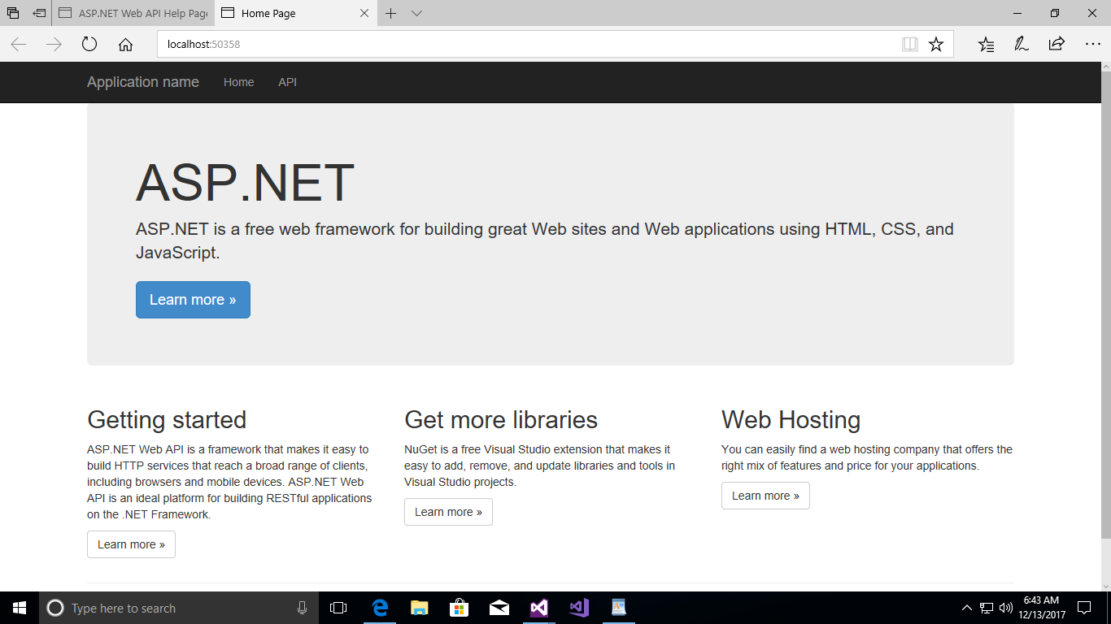

**Step 12:** Now your application will run as expected, then click on API link

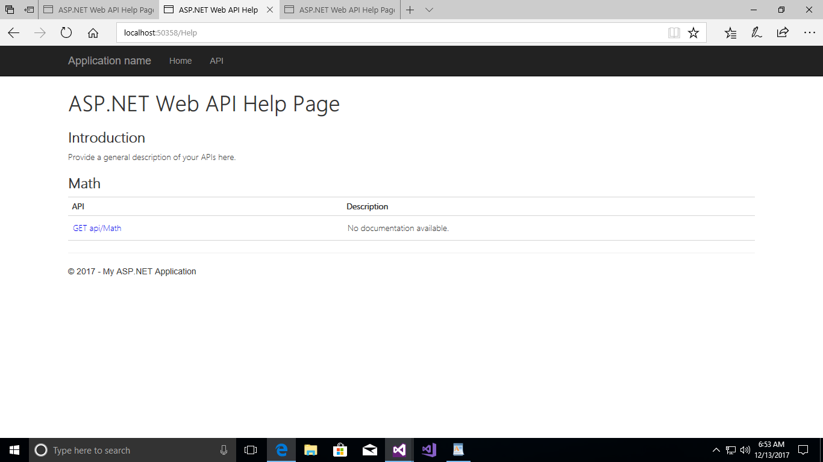

**Step 13:** Open “*WebApiConfig*” in ‘Solution Explorer’ and Configure with below code.

config.Routes.MapHttpRoute(

name: "ActionApi",

routeTemplate: "api/{controller}/{action}/{id}",

defaults: new { id = RouteParameter.Optional }

);

**NOTE:** The order should be same in “***WebConfig***” file. It means the code should be looks like below.

using System;

using System.Collections.Generic;

using System.Linq;

using System.Net.Http;

using System.Web.Http;

using Microsoft.Owin.Security.OAuth;

using Newtonsoft.Json.Serialization;

namespace CalDemo

{

public static class WebApiConfig

{

public static void Register(HttpConfiguration config)

{

// Web API configuration and services

// Configure Web API to use only bearer token authentication.

config.SuppressDefaultHostAuthentication();

config.Filters.Add(new HostAuthenticationFilter(OAuthDefaults.AuthenticationType));

// Web API routes

config.MapHttpAttributeRoutes();

config.Routes.MapHttpRoute(

name: "ActionApi",

routeTemplate: "api/{controller}/{action}/{id}",

defaults: new { id = RouteParameter.Optional }

);

config.Routes.MapHttpRoute(

name: "DefaultApi",

routeTemplate: "api/{controller}/{id}",

defaults: new { id = RouteParameter.Optional }

);

}

}

}

**Step 14:** Save all and run the application (F5), then select **API** link on top of the page.

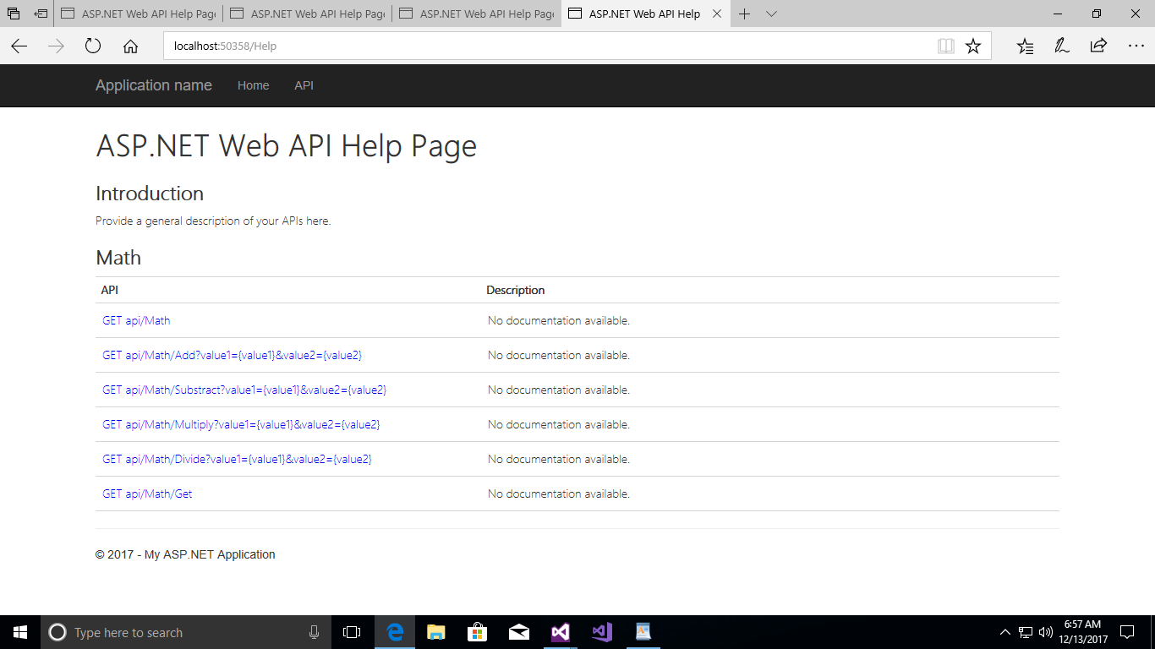

**Step 15:** Now you should configure Swagger in your application. If you will check now in App_Start folder there has no Swagger config file.

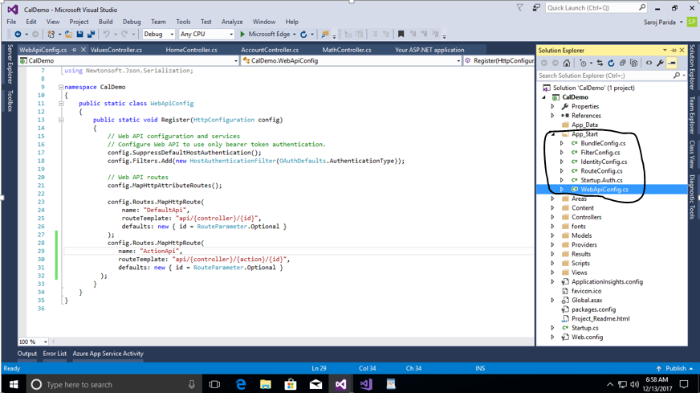

**Step 16:** In ‘Solution Explorer’ right click on your project->Manage NuGet Packages.

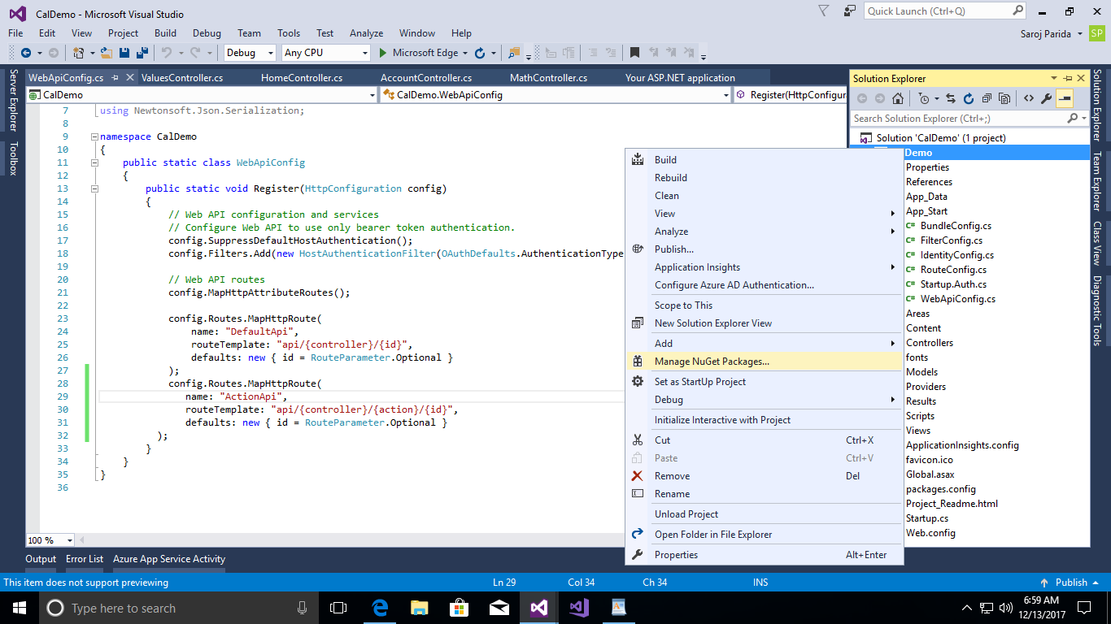

**Step 17:** Browse with swagger key word and install the latest version.

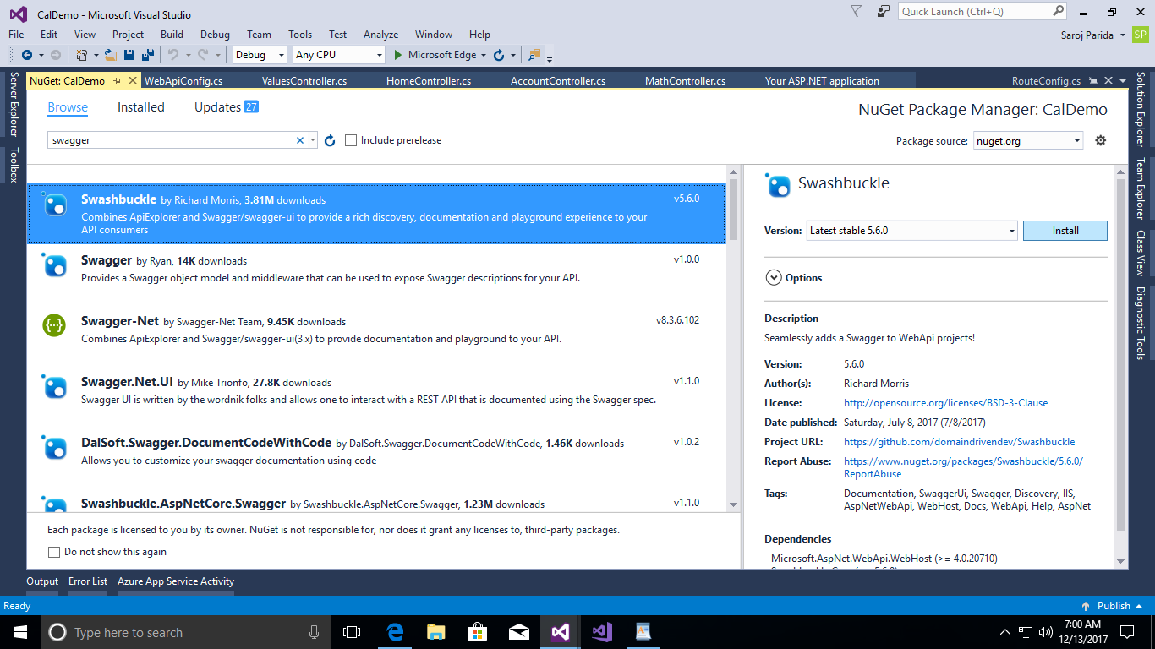

**Step 18:** Now you can see a pop-up looks like below.

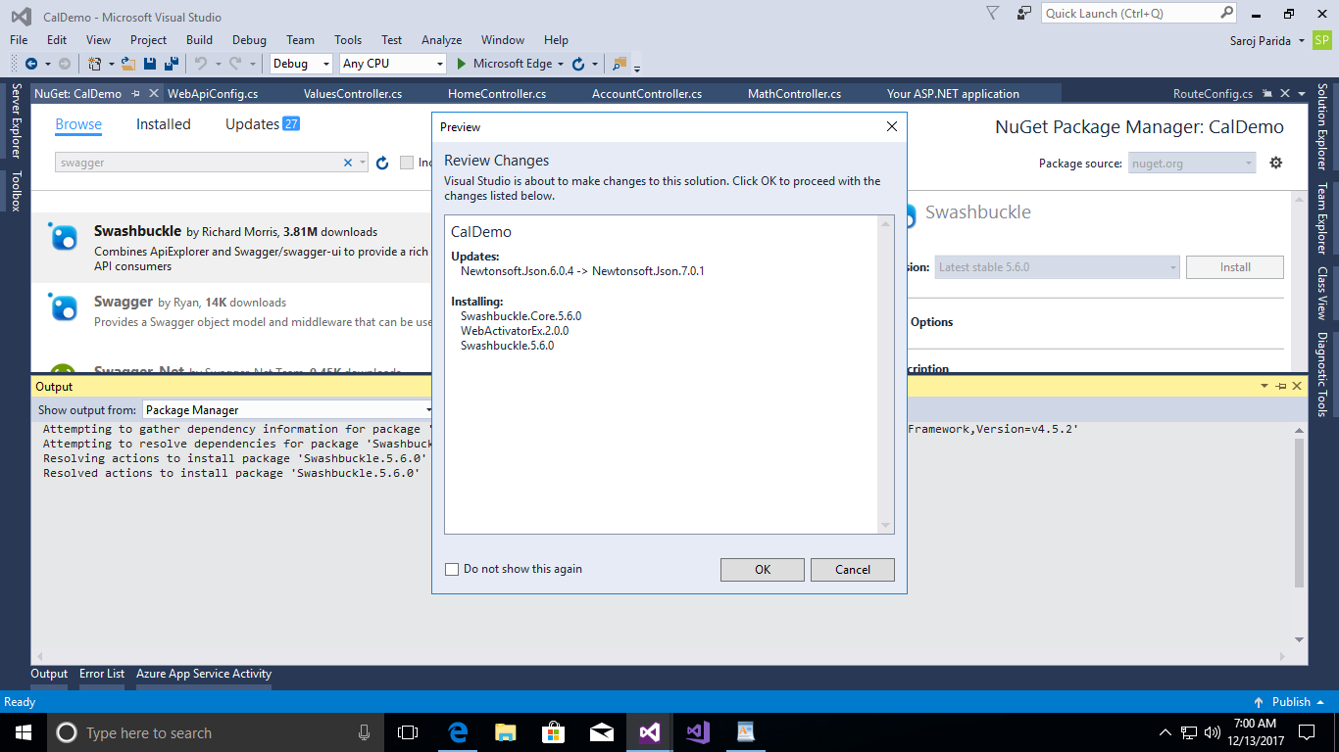

**Step 19:** Click on ‘OK’.

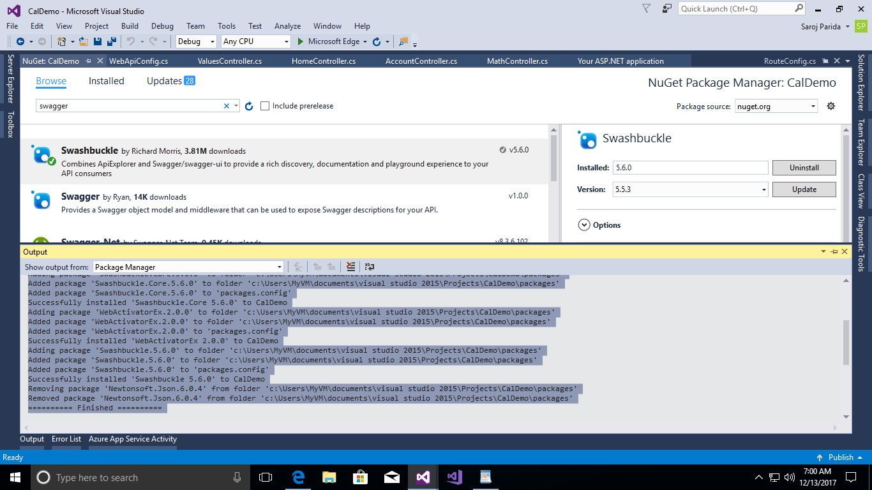

**Step 20:** Check in “Solution Explorer” in App_Start folder, now you can see a new file added SwaggerConfig.cs.

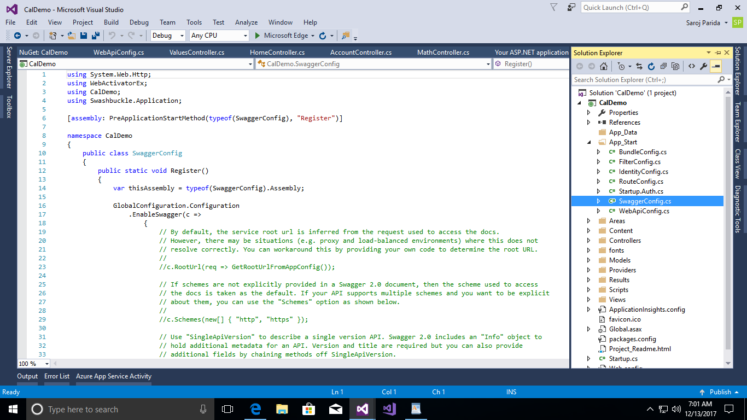

**Step 21:** Add Swagger link in Home index page. Open Layout page and add below code.

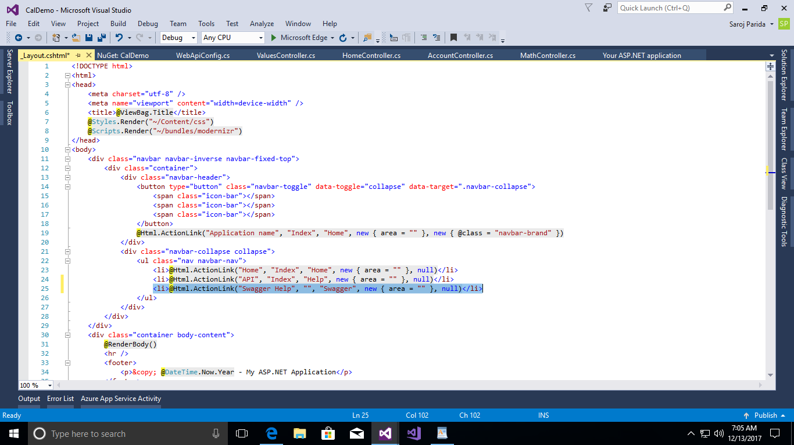

<li>@Html.ActionLink("Swagger Help", "", "Swagger", new { area = "" }, null)</li>

**Step 22:** Save change code and run application (F5) and click on “Add Swagger” link.

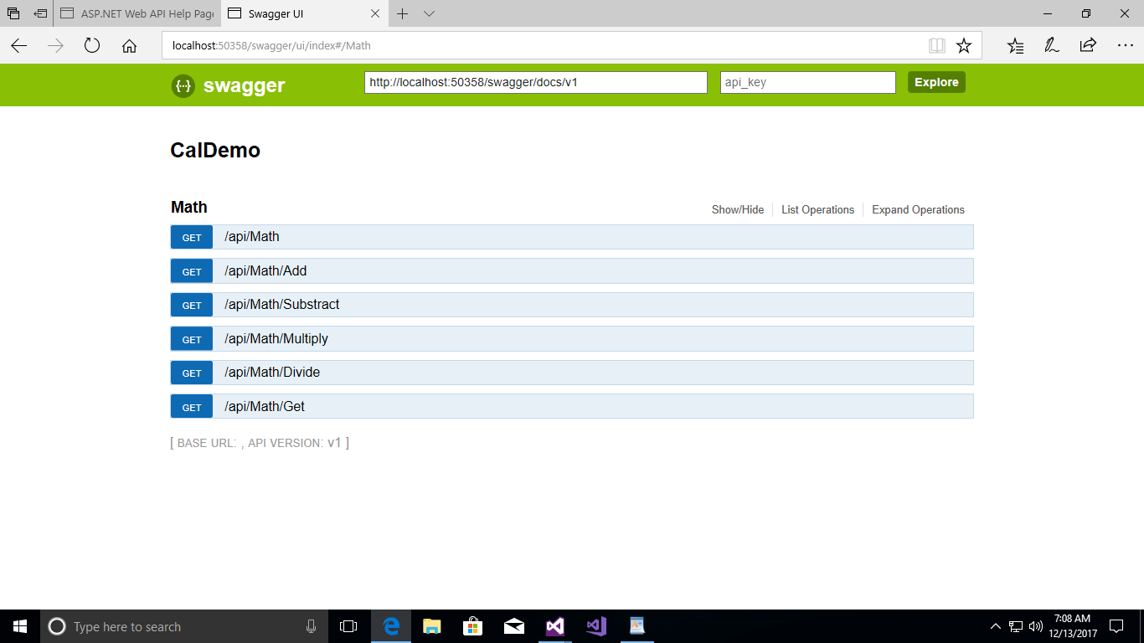

**Step 23:** Now your Web API is ready to deploy into Azure Cloud.

1. **Publish this Web API to an Azure web app (Host/deploy our services to Azure)**

**Step 1:** Login in your Azure accounts and create a website.

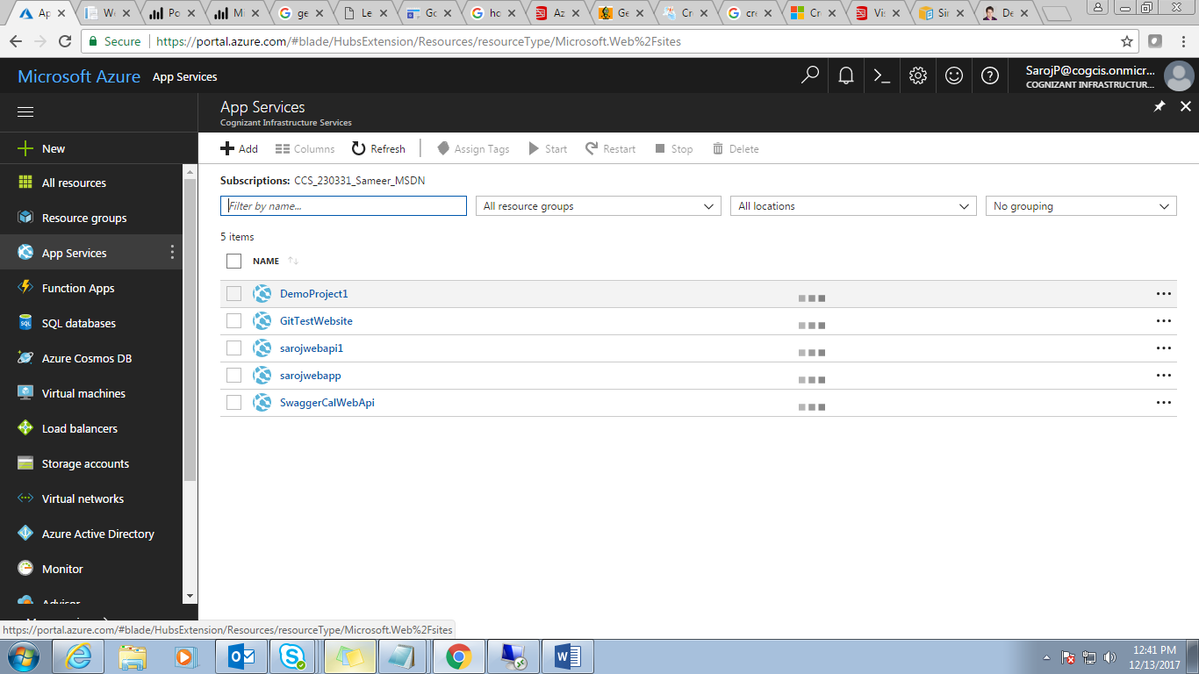

**Step 2:** Click on “Add” button and select “Web App” image.

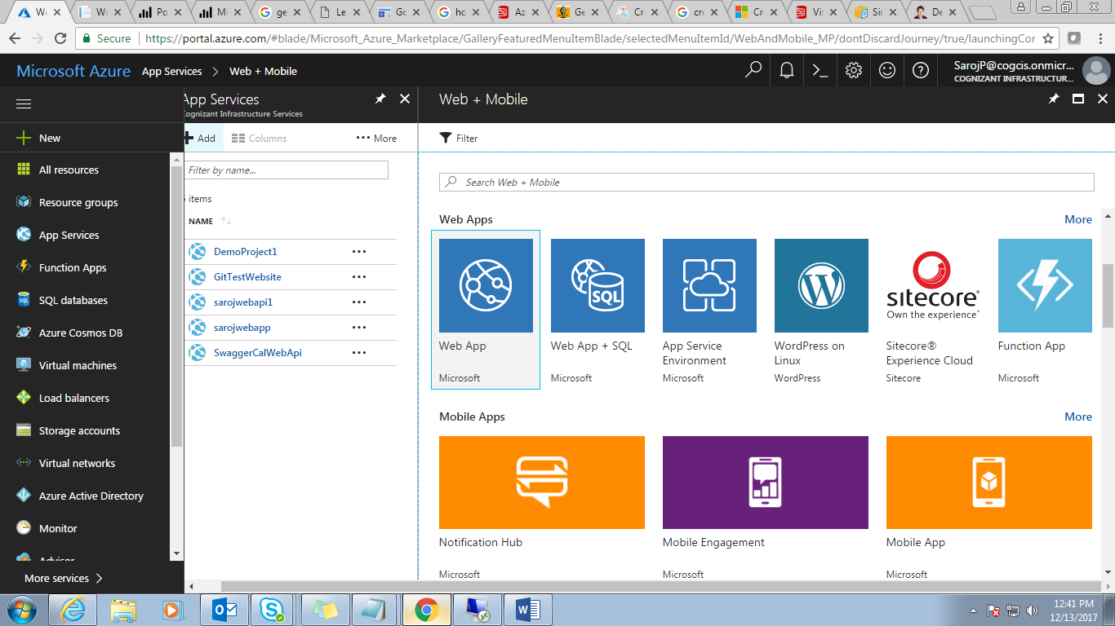

**Step 3:** After select image type you will get a screen looks like below.

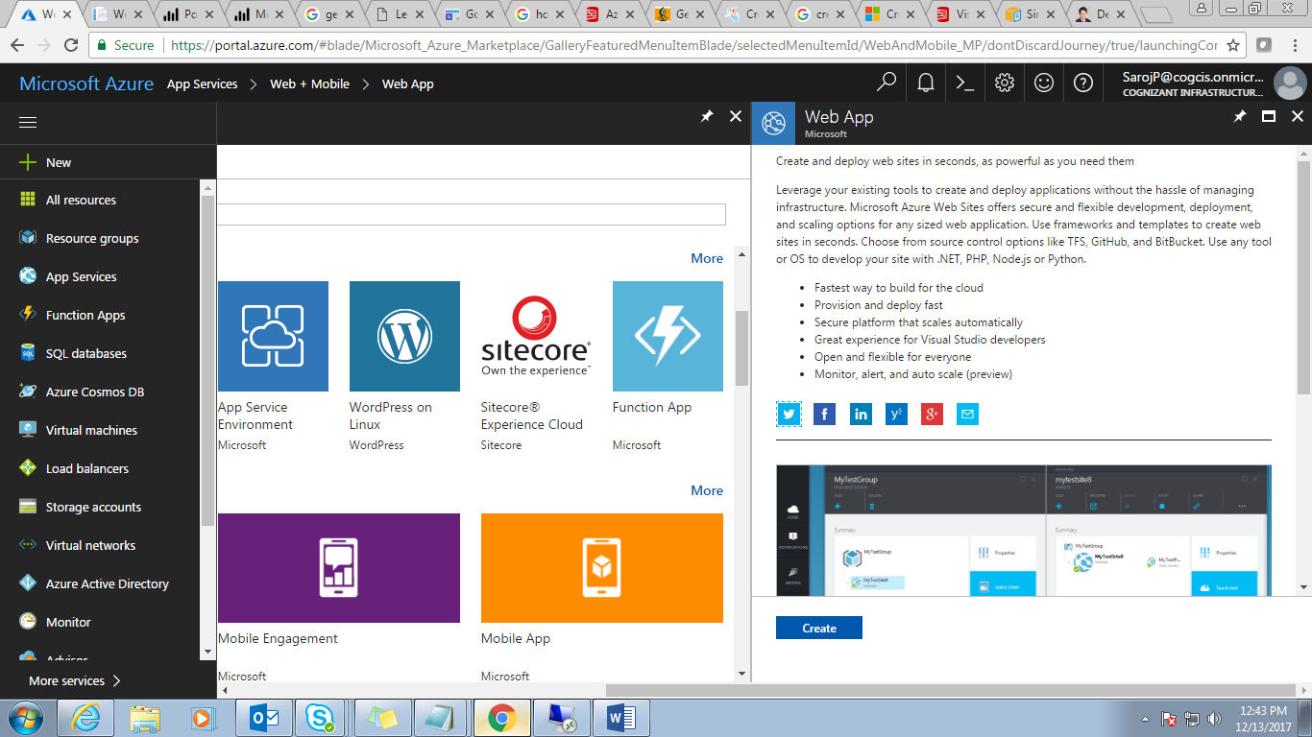

**Step 4:** Click on ***Create*** button.

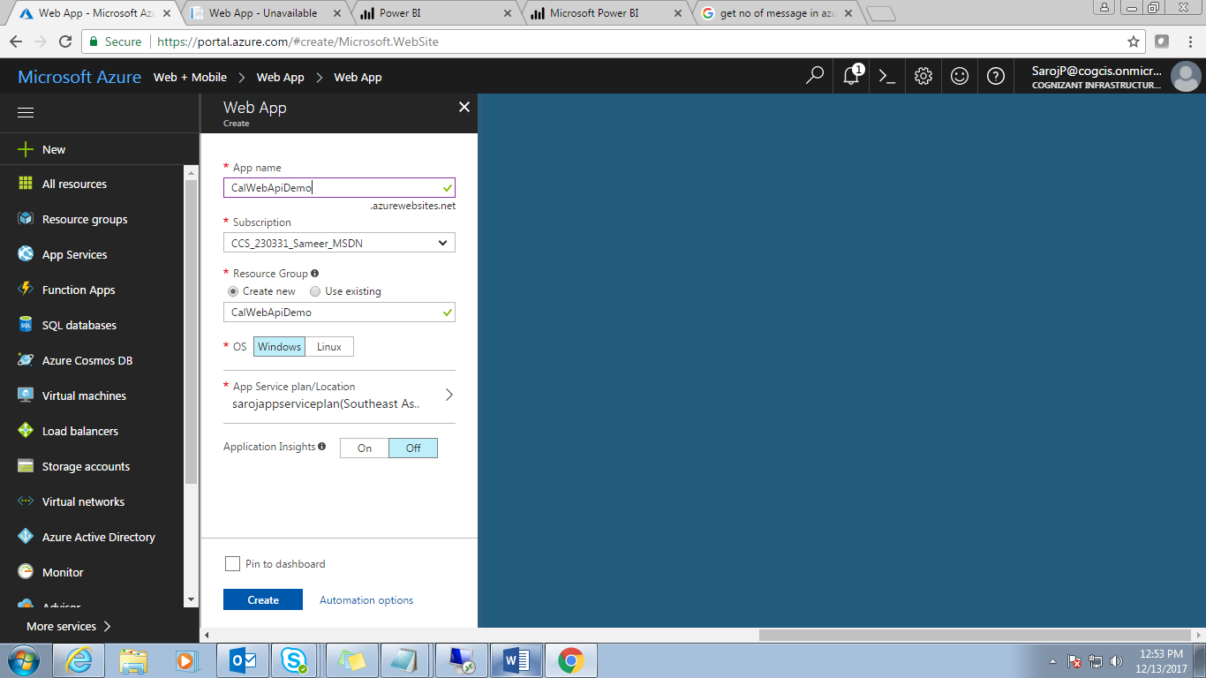

**Step 5:** Enter App name along with other info, then click on ***Create***.

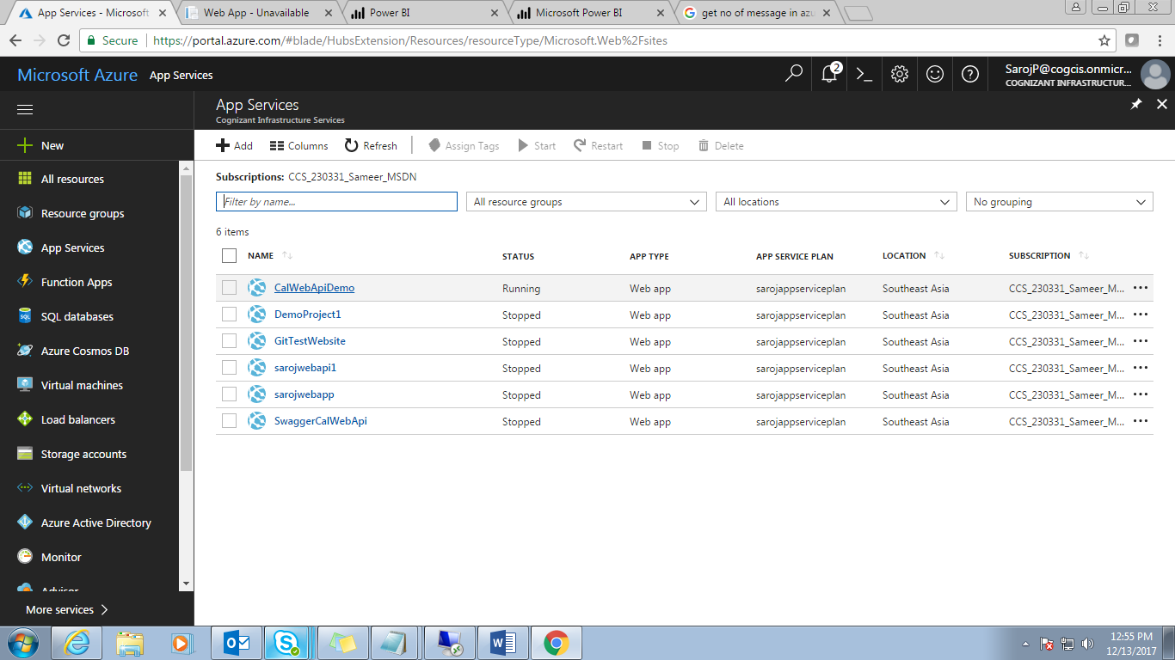

**Step 6:** After creating a new web application in an azure portal, click on that website to validate whether it is created successfully or not.

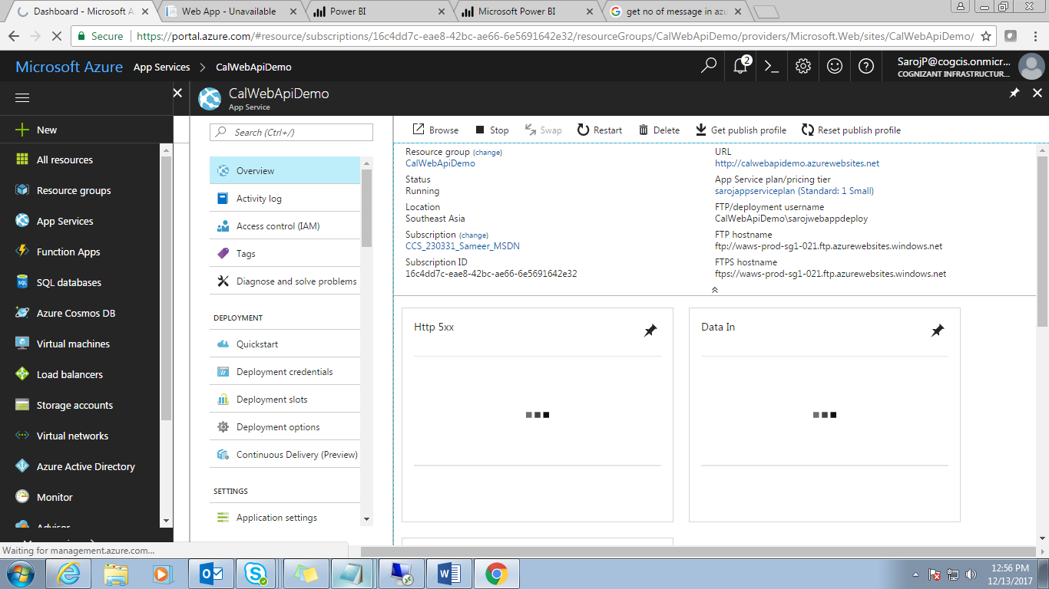

**Step 7:** Click on ***URL*** to check the created website.

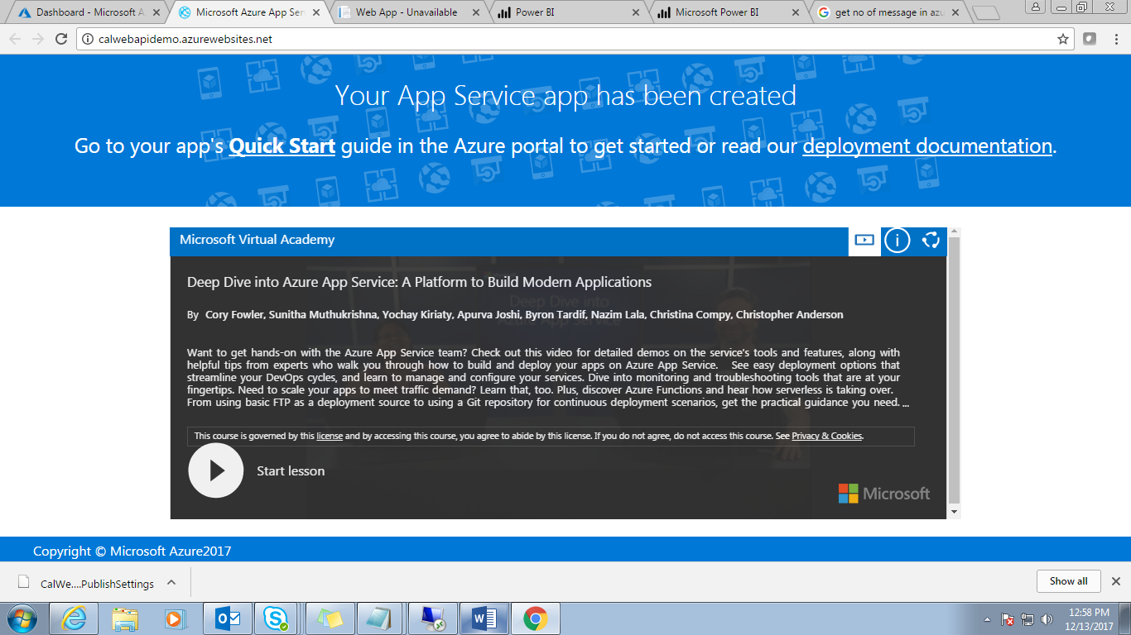

It has been created successfully.

**Step 8:** Download “***Get Publish profile***” in azure portal.

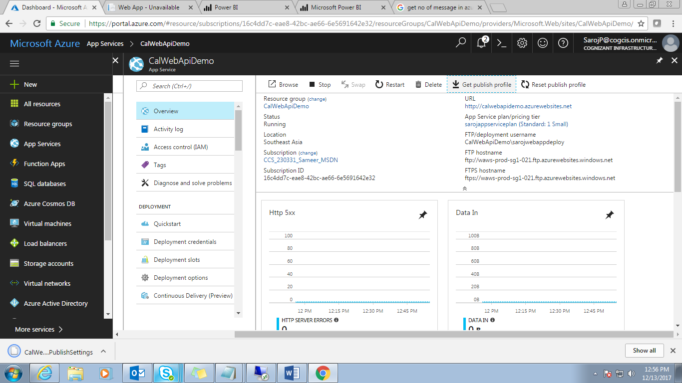

**Step 9:** Then go to Visual studio for deploy “***CalwebApi***” application into this newly created azure website.

Open application and follow below steps.

Right click on project in ‘Solution Explorer’->Publish

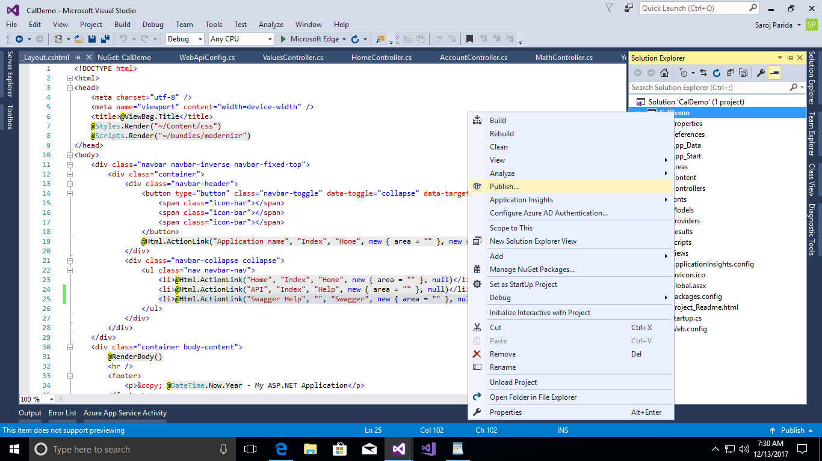

**Step 10:** You will get a pop-up looks like below screen shot.

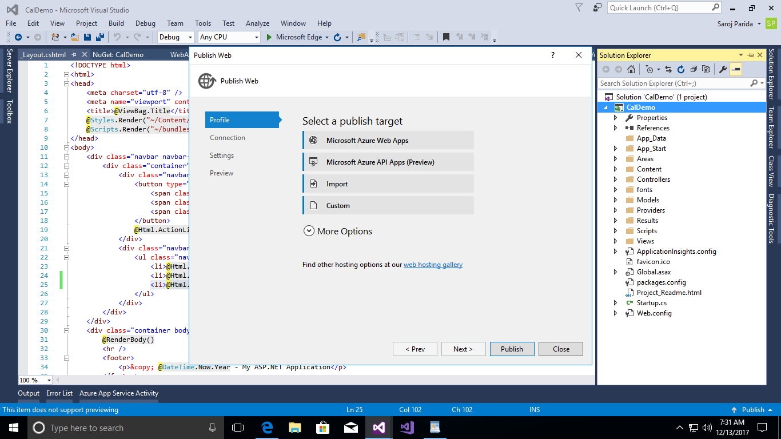

**Step 11:** Click on ***Import*** link

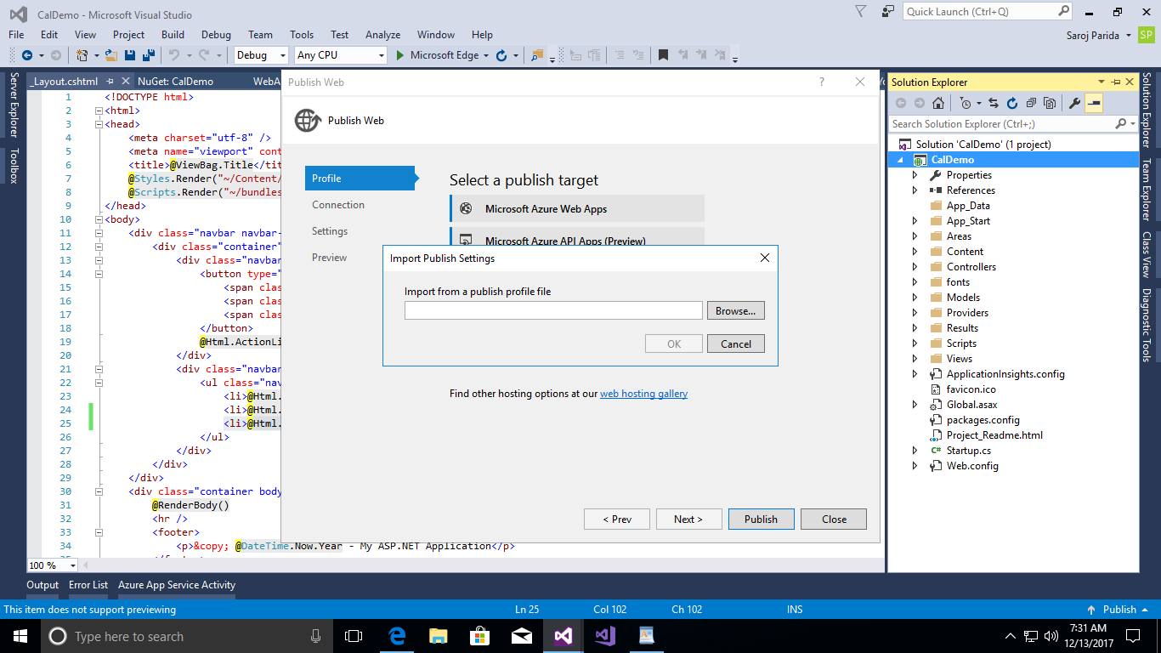

**Step 12:** Browse the downloaded “***CalWebApiDemo.PublishSettings***” file.

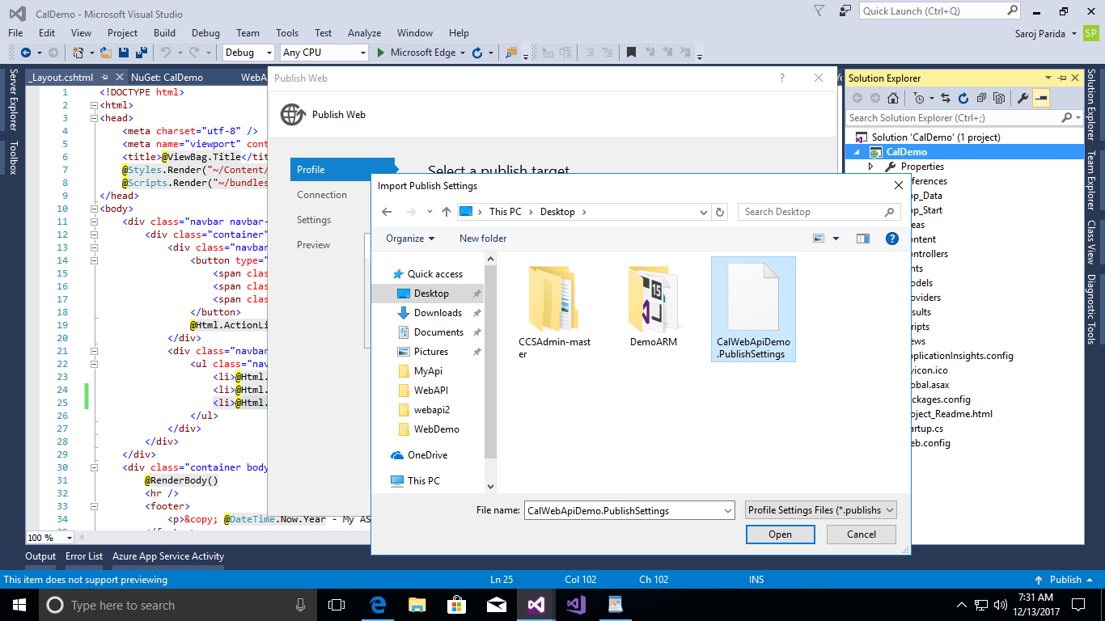

**Step 13:** Click on ***Open*** then ***OK.***

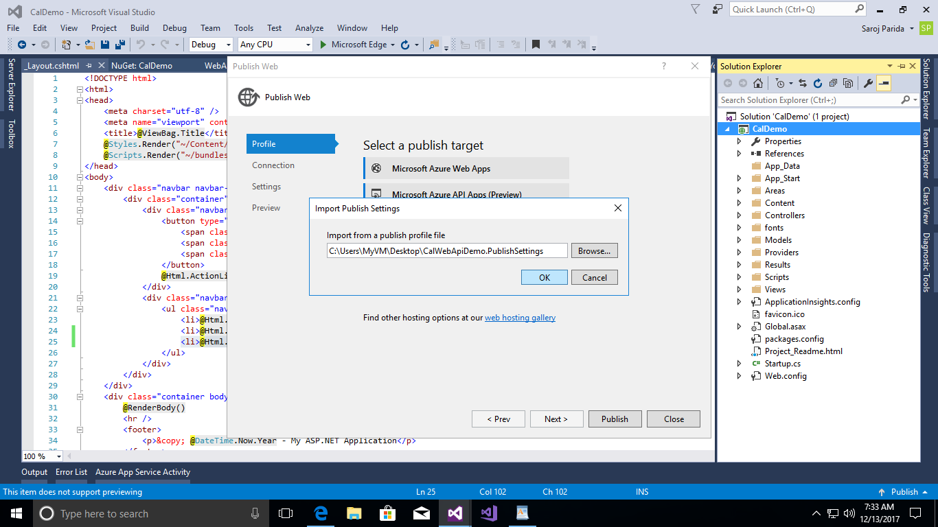

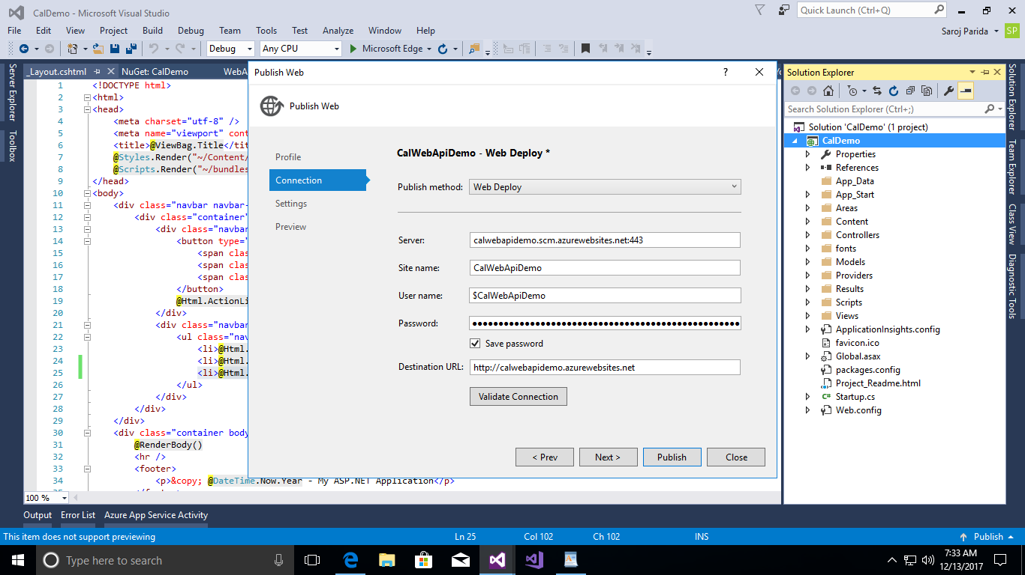

**Step 14:** Click on ***Next.***

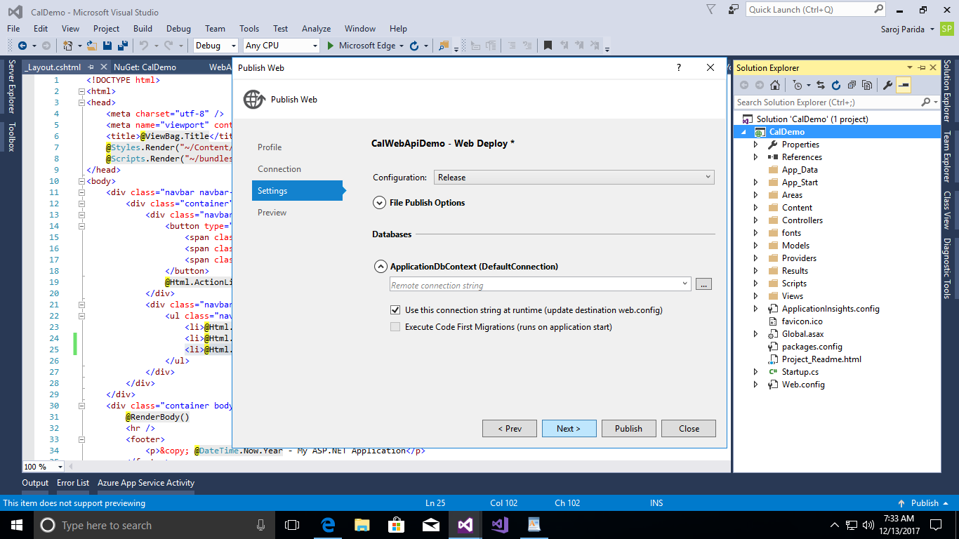

**Step 15:** Click on ***Next.***

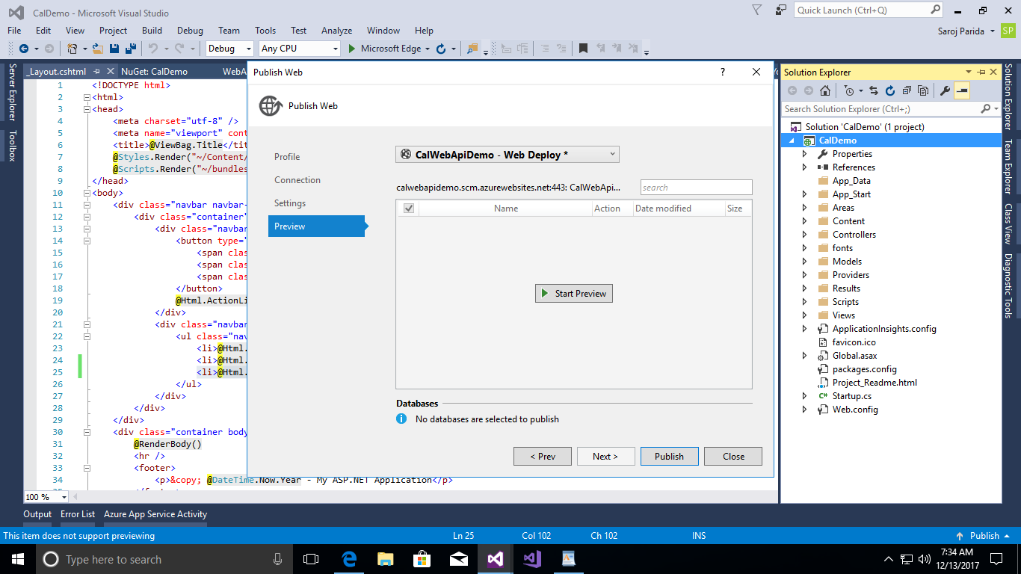

**Step 16:** Click “***Start*** ***Preview***” to see all the file and contents and then click on ***Publish.***

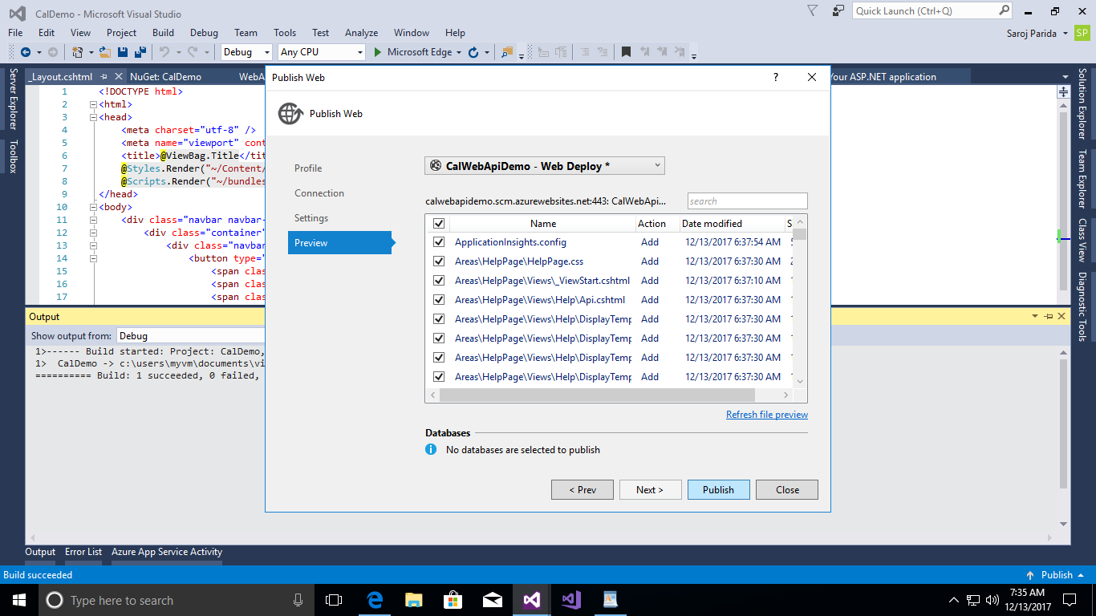

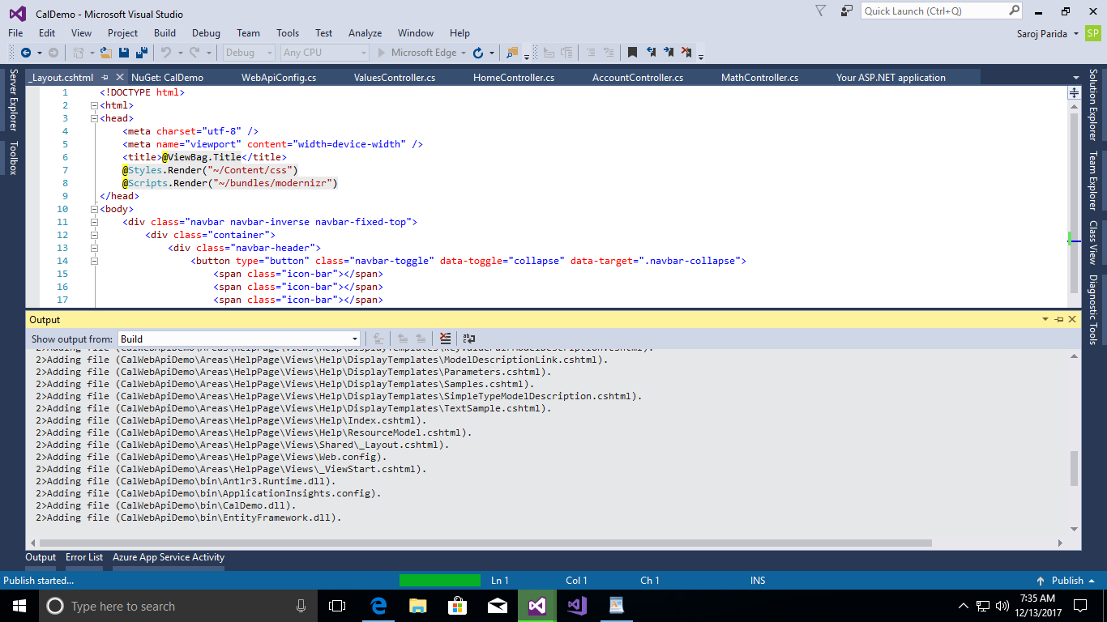

**Step 17:** After deploying successfully, it will redirect to the web site automatically.

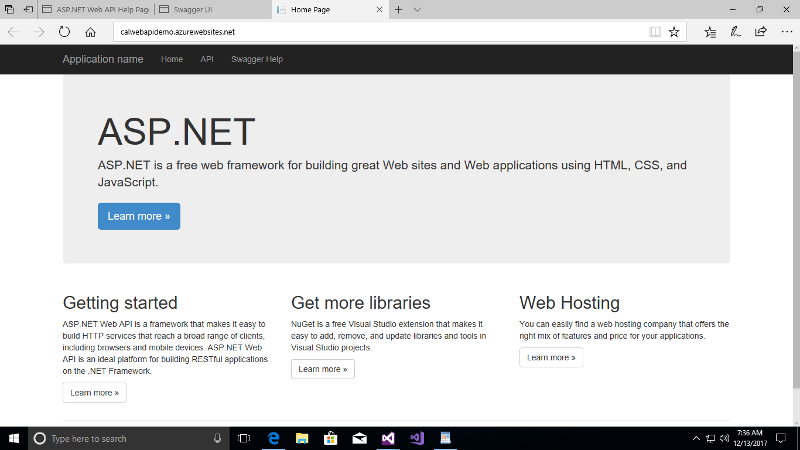

**Step 18:** Now your application successfully deployed in azure cloud. Click on “***Swagger Help***” link to check.

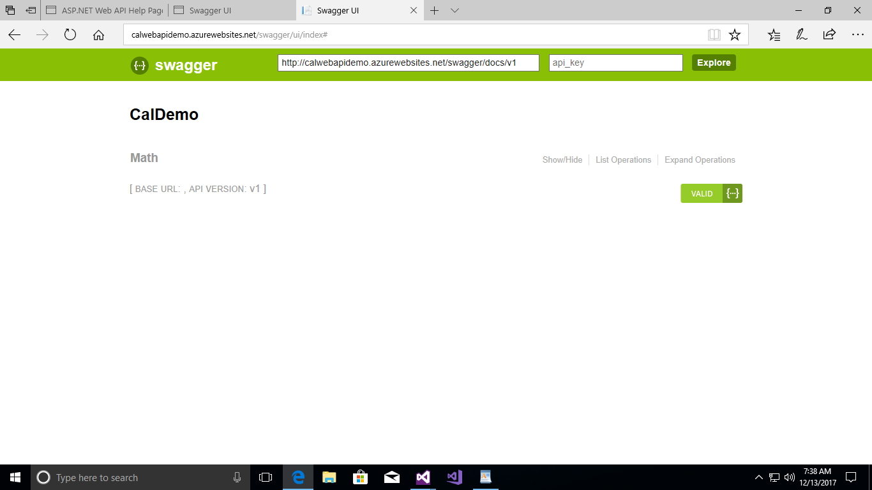

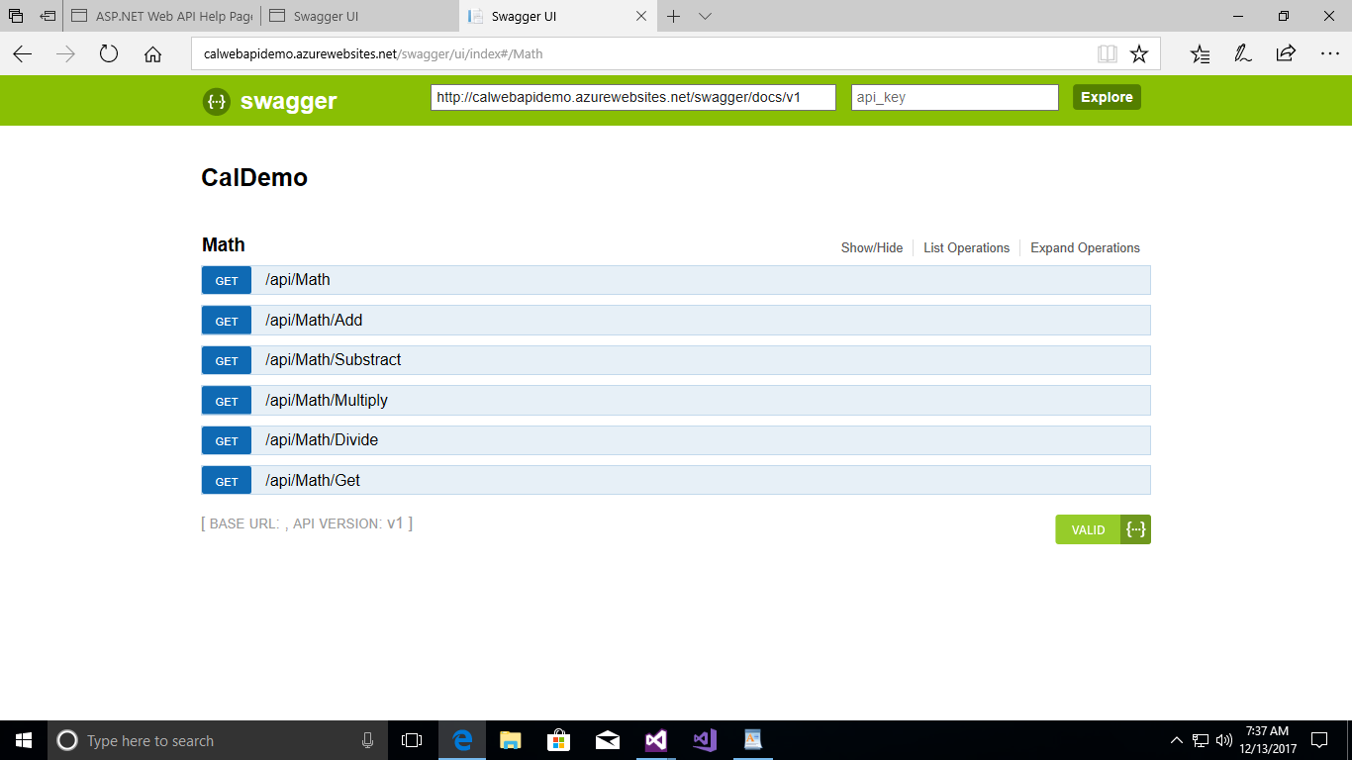

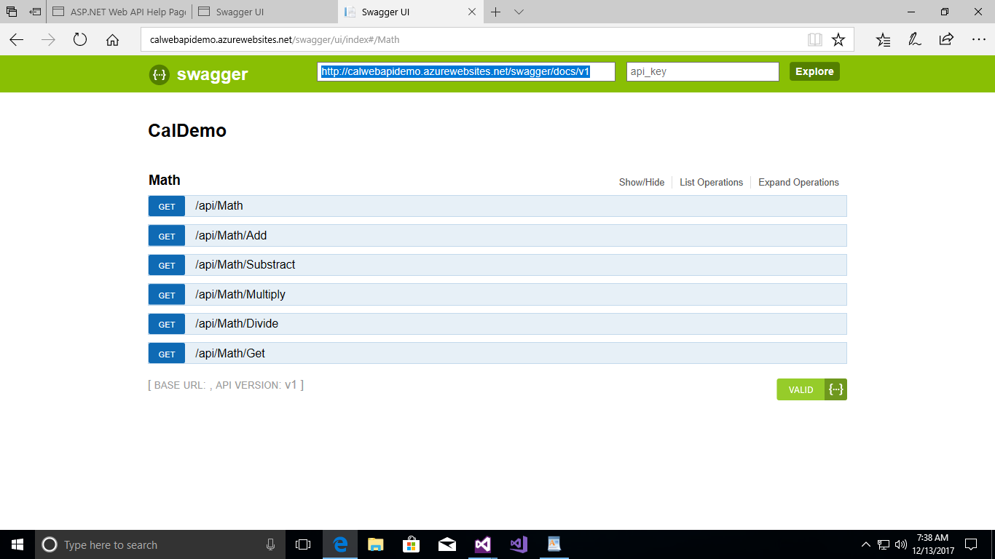

**Step 19:** Now this Web API is ready to deploy into ***Azure API Management***.

**NOTE:** Copy this Swagger app_key for ***Azure API management***.

<http://calwebapidemo.azurewebsites.net/swagger/docs/v1>

1. **Publish to Azure Management API(Manage our services using Azure API Management)**

**Step 1:** Create a new ***API Management*** in your Azure Portal. Search API Management image in Azure portal like below.

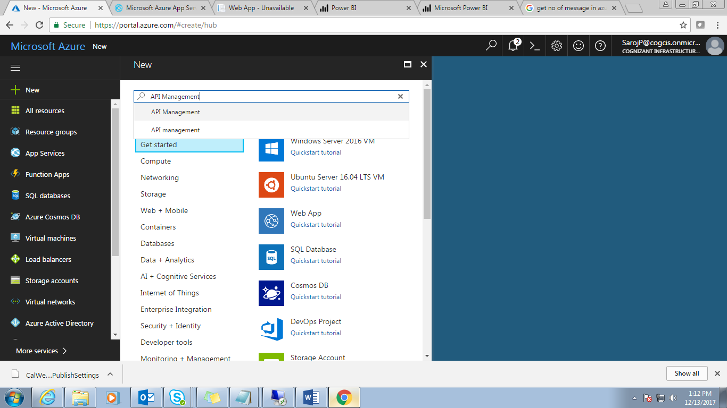

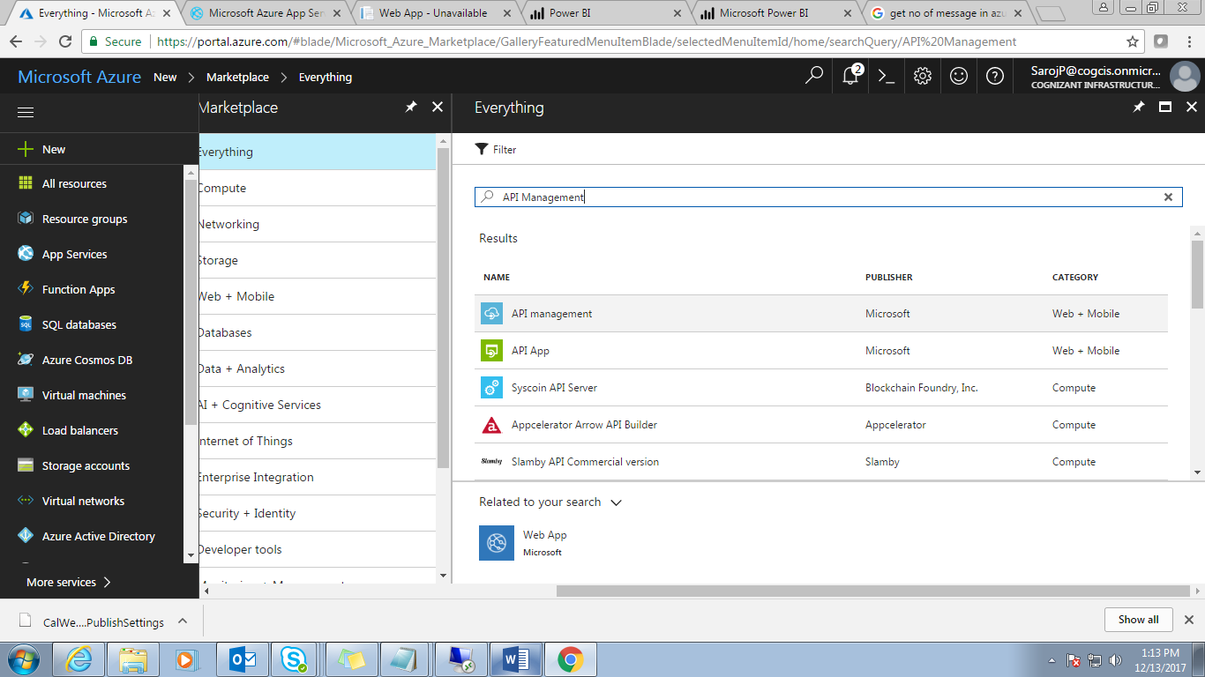

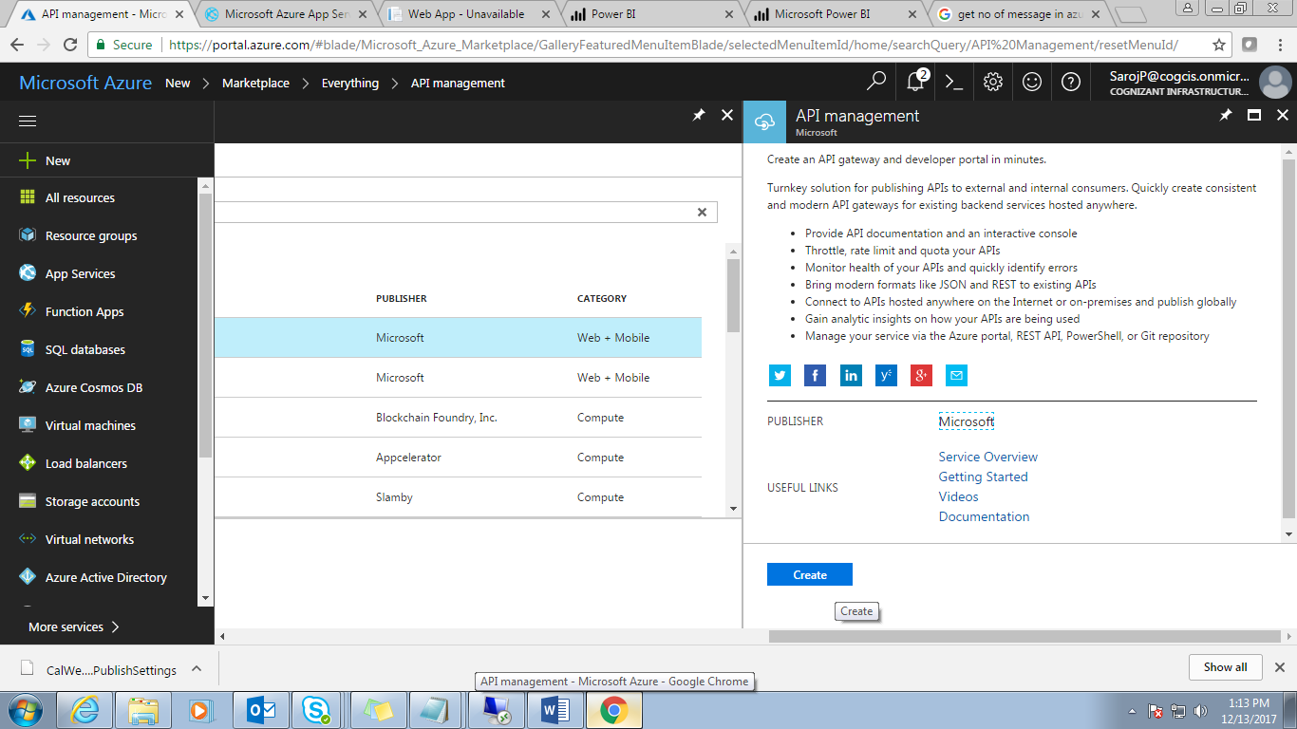

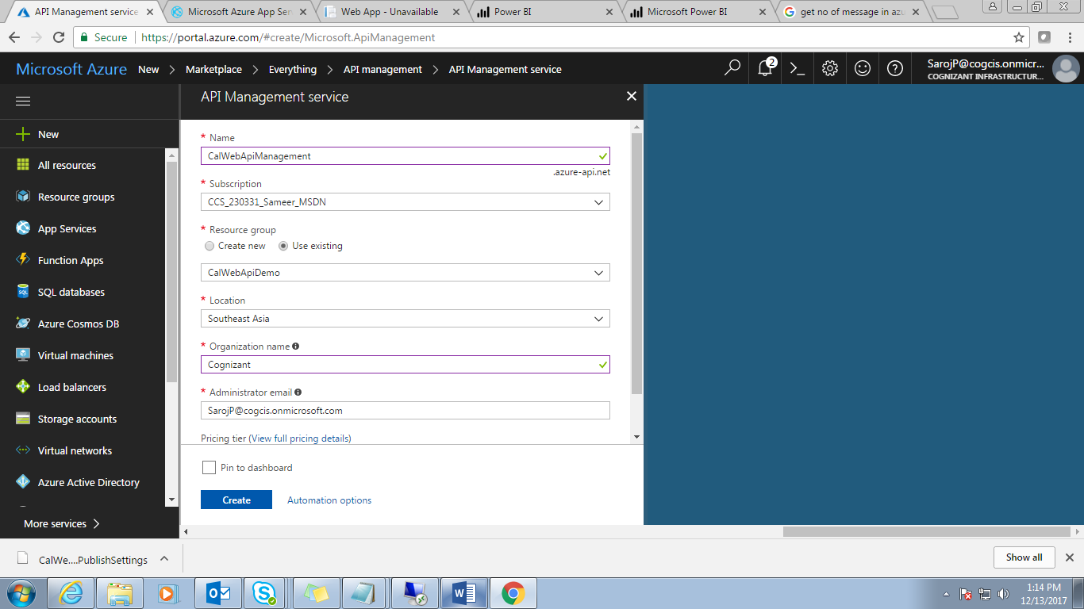

**Step 2:** Enter the Name of ‘API Management service’ and other information click on ***Create***.

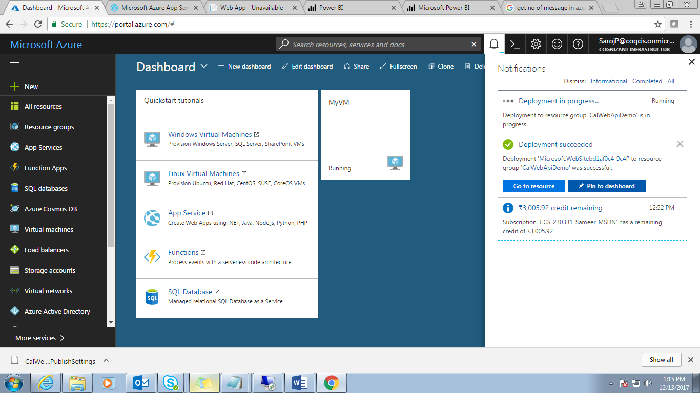

**Step 3:** It will take a moment to create. Once created it will populate in azure portal like below

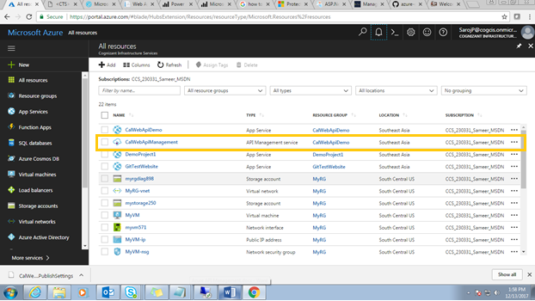

**Step 4:** Click on created “***Azure API Management***” link.

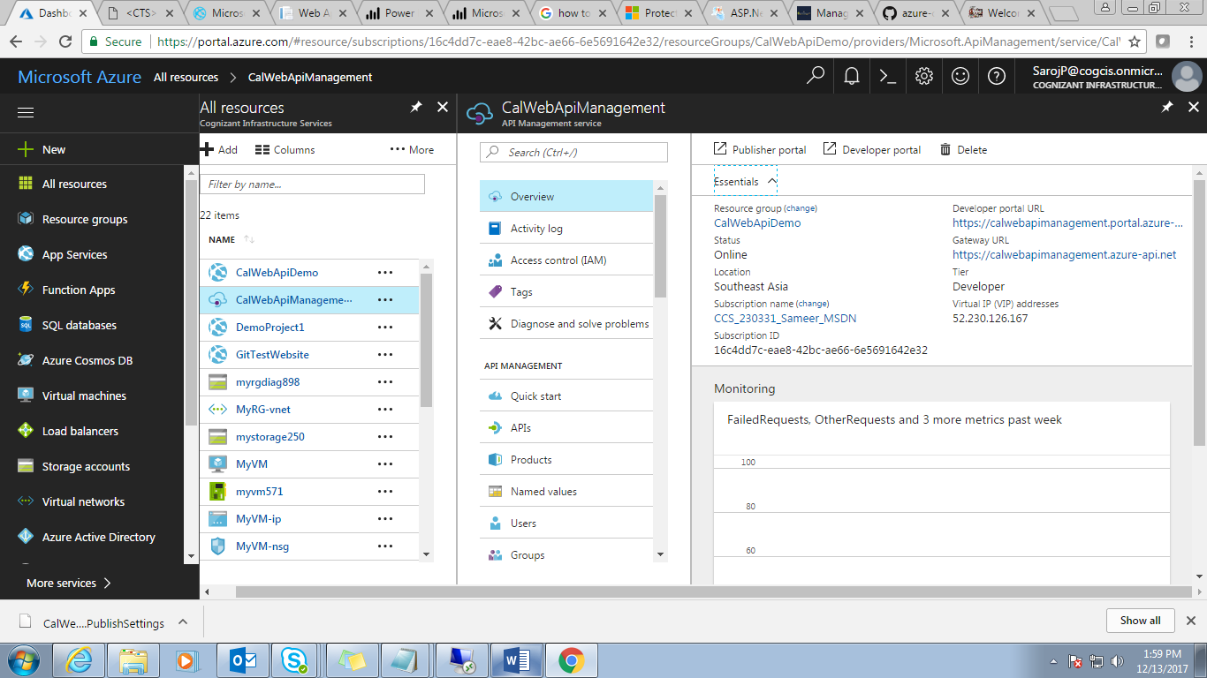

**Step 5:** Click on “***Developer portal URL***” to check.

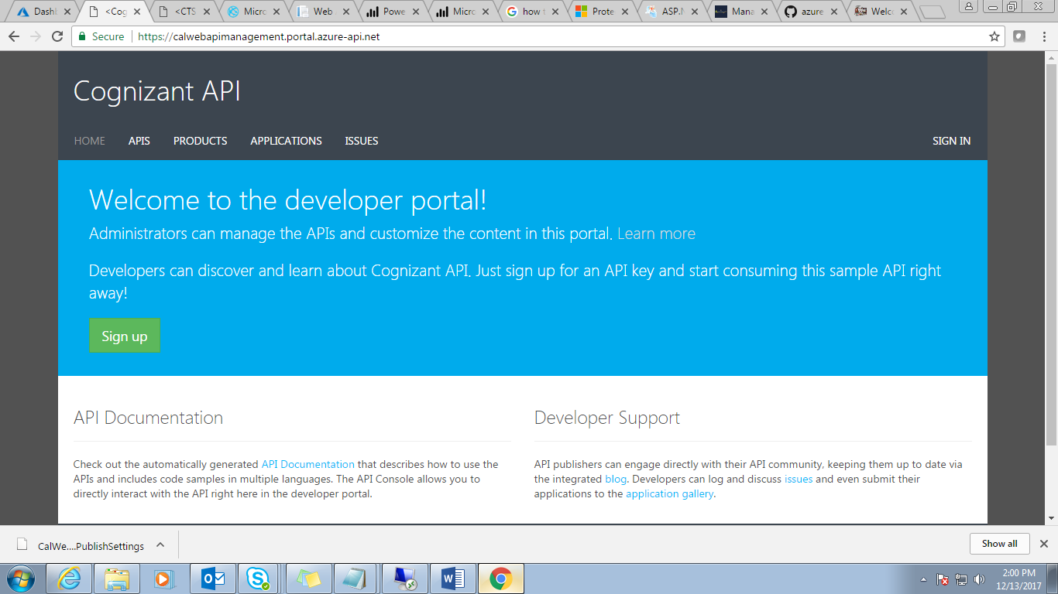

**Step 6:** Click on ***APIs*** link.

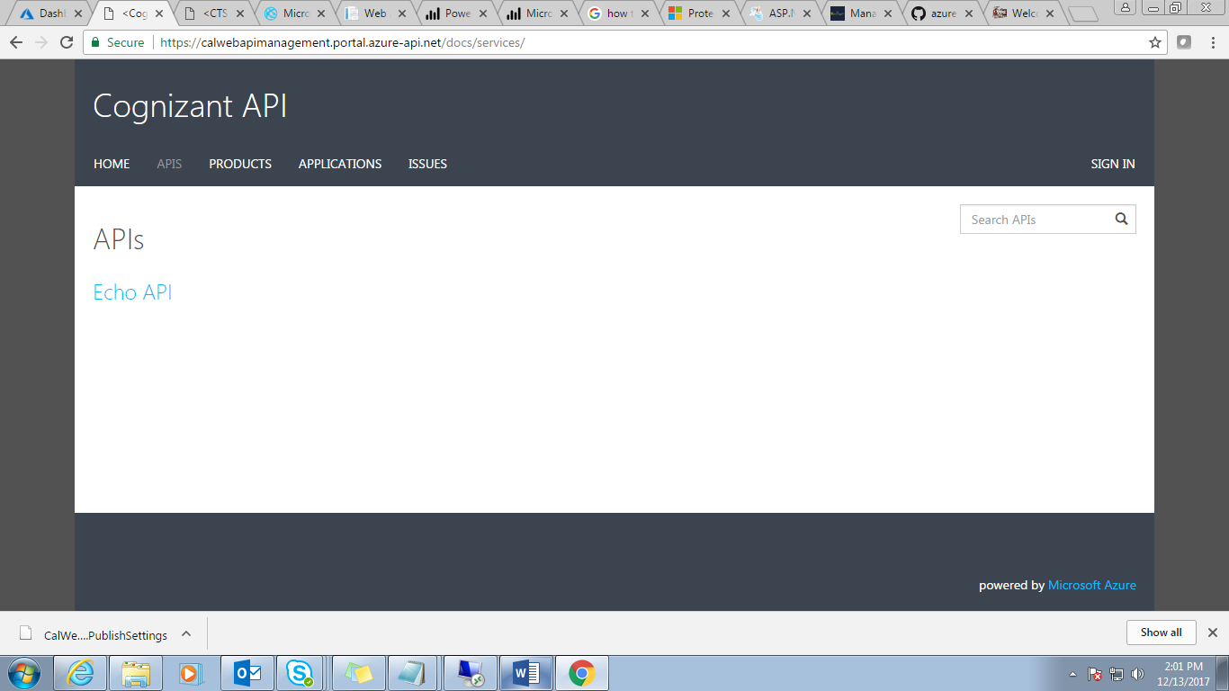 **Step 7:** There should be a default API is ‘Echo API’.

Then Click on ***Products*** link.

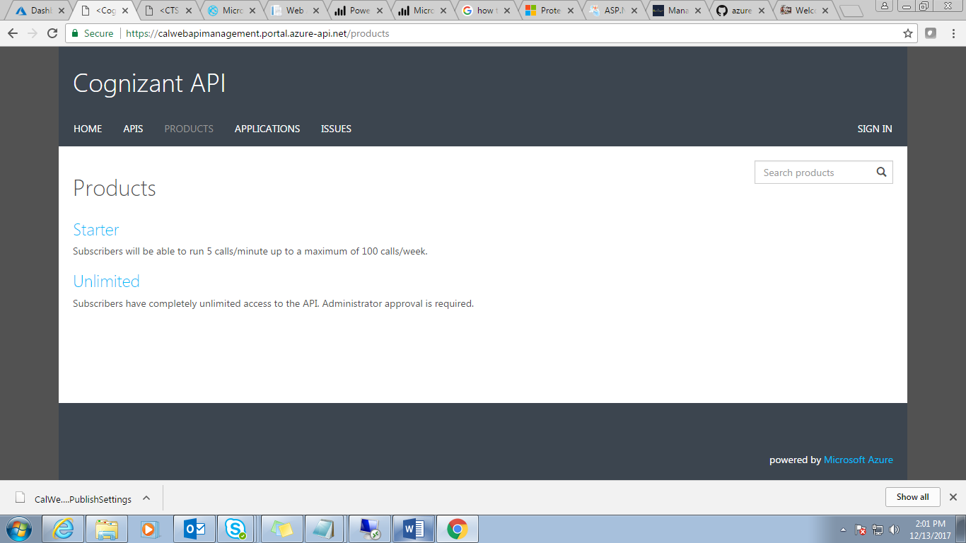

**Step 8:** Two default products should be there ***Starter*** and ***Unlimited***.

Now you go back to your Azure API Management portal.

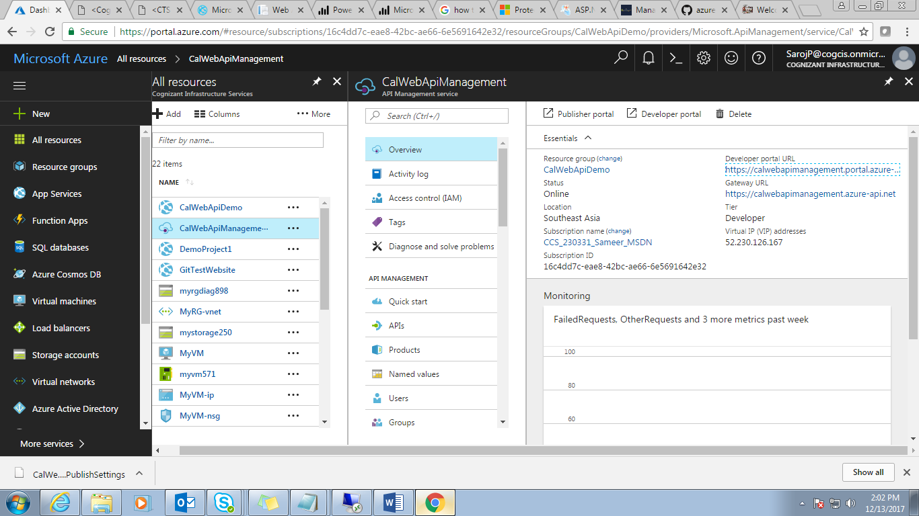

**Step 9:** Click on “***Publisher Portal***” link.

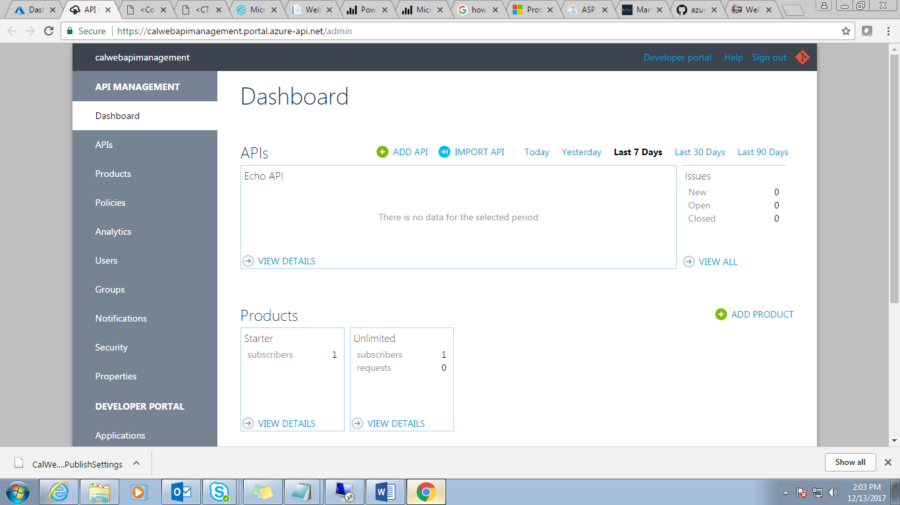

**Step 10:** Click on “***Import API***” link for import “***CalWebApi”*** application which is already deployed into azure and copied the swagger ***URL***.

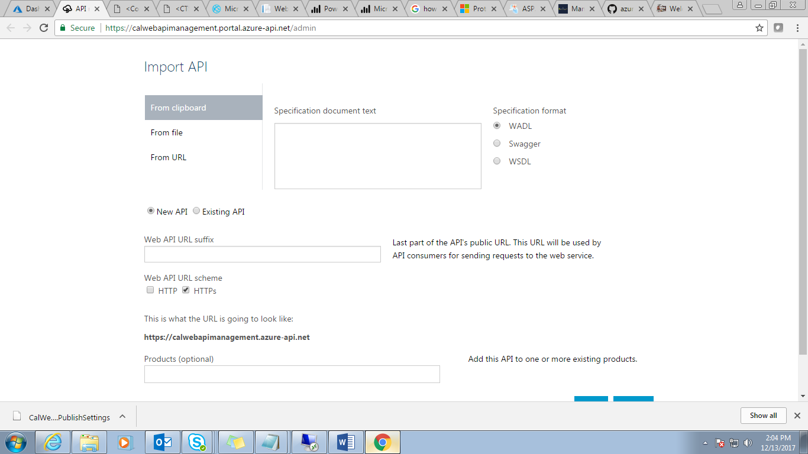

**Step 11:** Select “***From URL***” and “***Swagger***”.

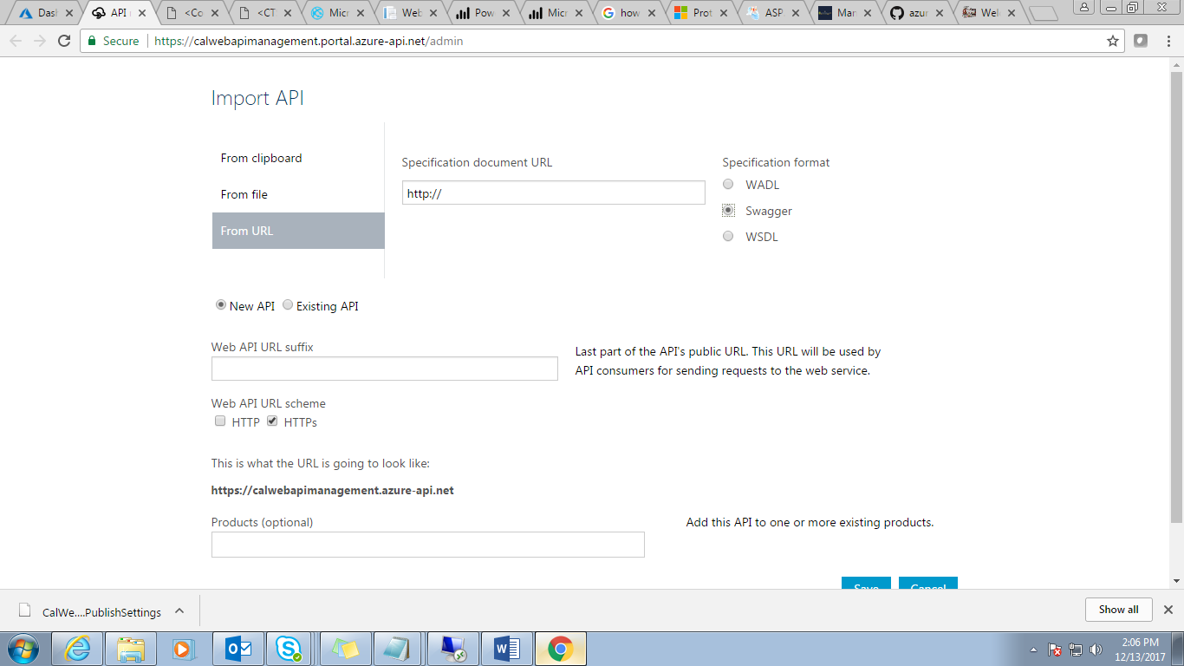

**Step 12:** Now paste the ***Swagger URL*** copied before.

<http://calwebapidemo.azurewebsites.net/swagger/docs/v1>



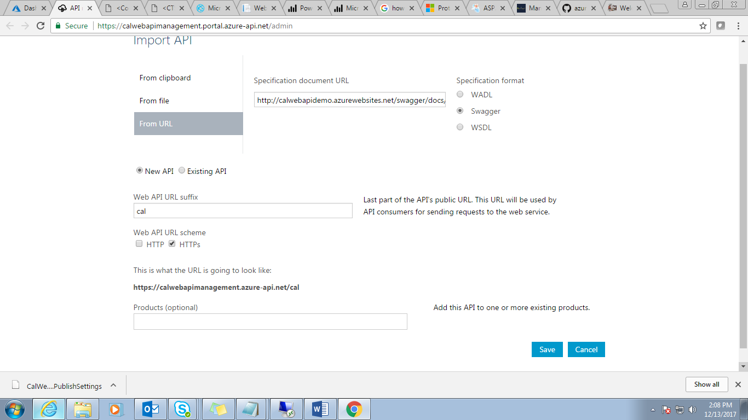

**Step 13:** Click on ***Save*** button.

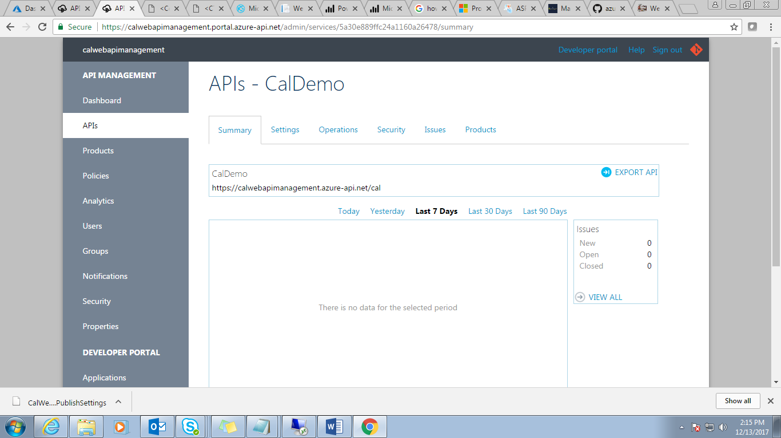

**Step 14:** API created successfully “***CalDemo***”.

Now click on “***Operations***” tab and check all methods defined in your Web API.

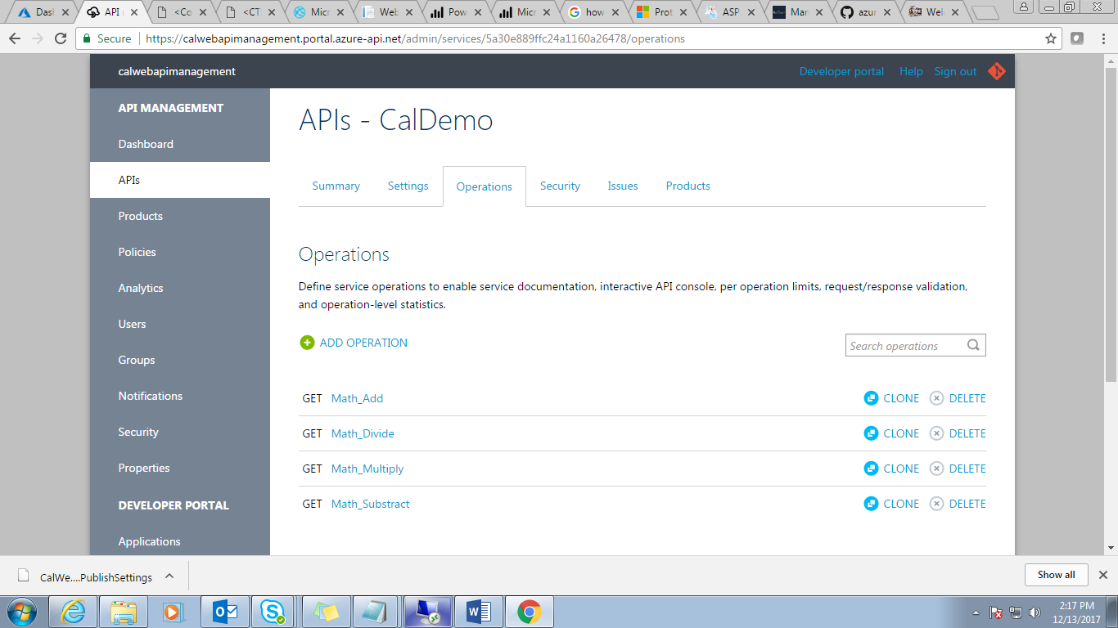

**Step 15:** Check “***Product***” tab in this API.

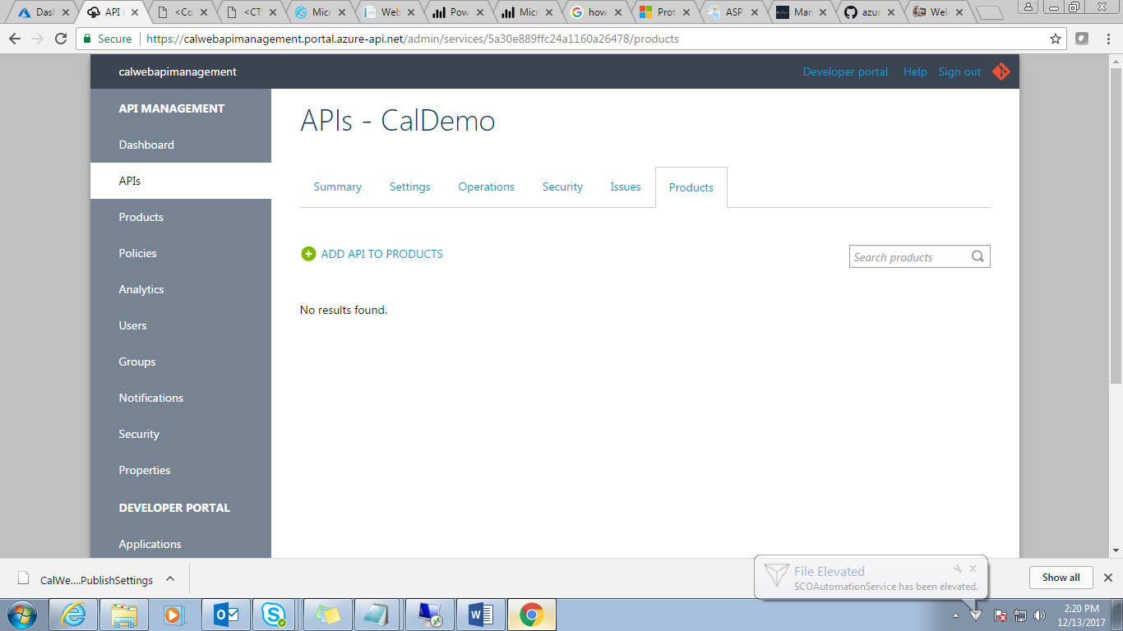

**Step 16:** No products are available in this API.

Now add “***Product***” here. Click on ***Products*** tab in left panel.

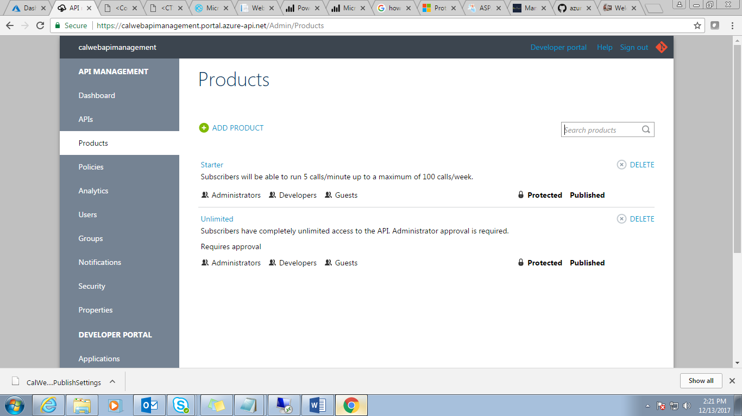

**Step 17:** Two default products should be there ***Starter*** and ***Unlimited***. If you want to add a product then click on “***Add Product***”.

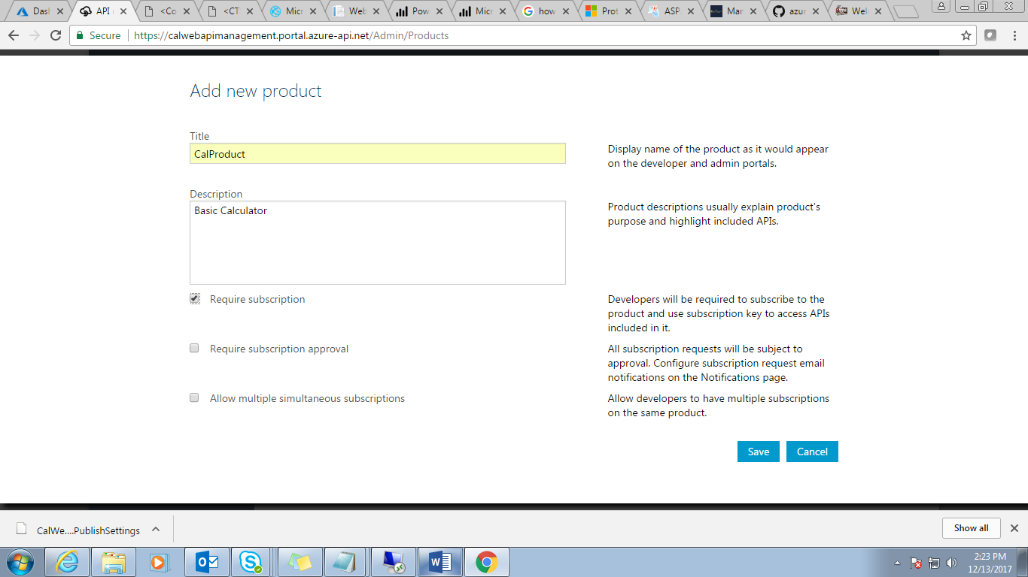

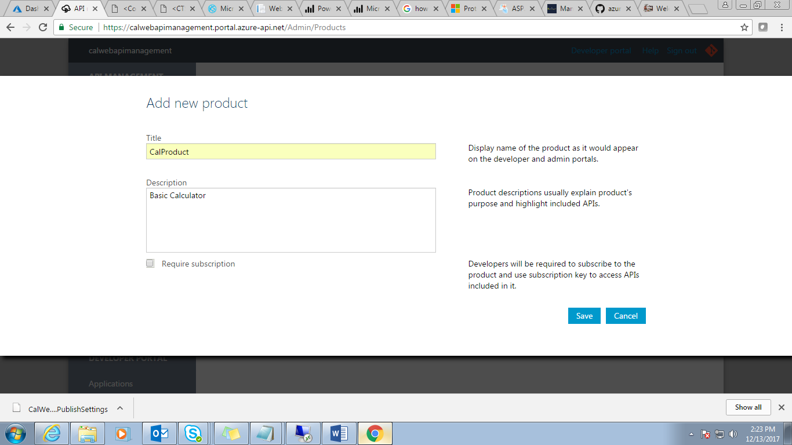

**Step 18**: Click on ***Save*** button.

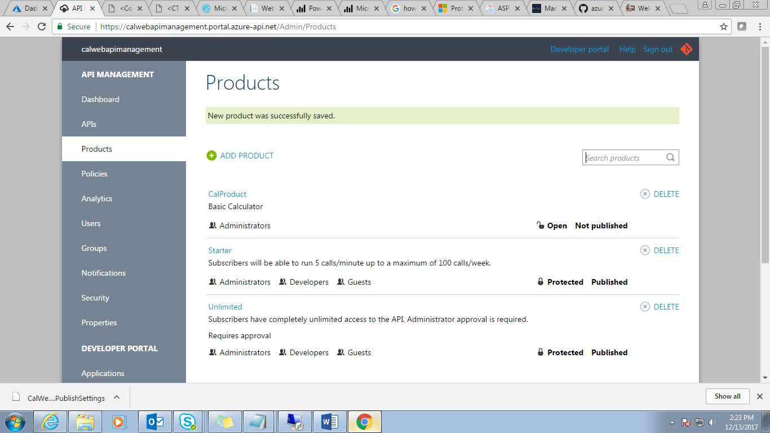

**Step 19:** Click on newly created “***CalProduct***” link.

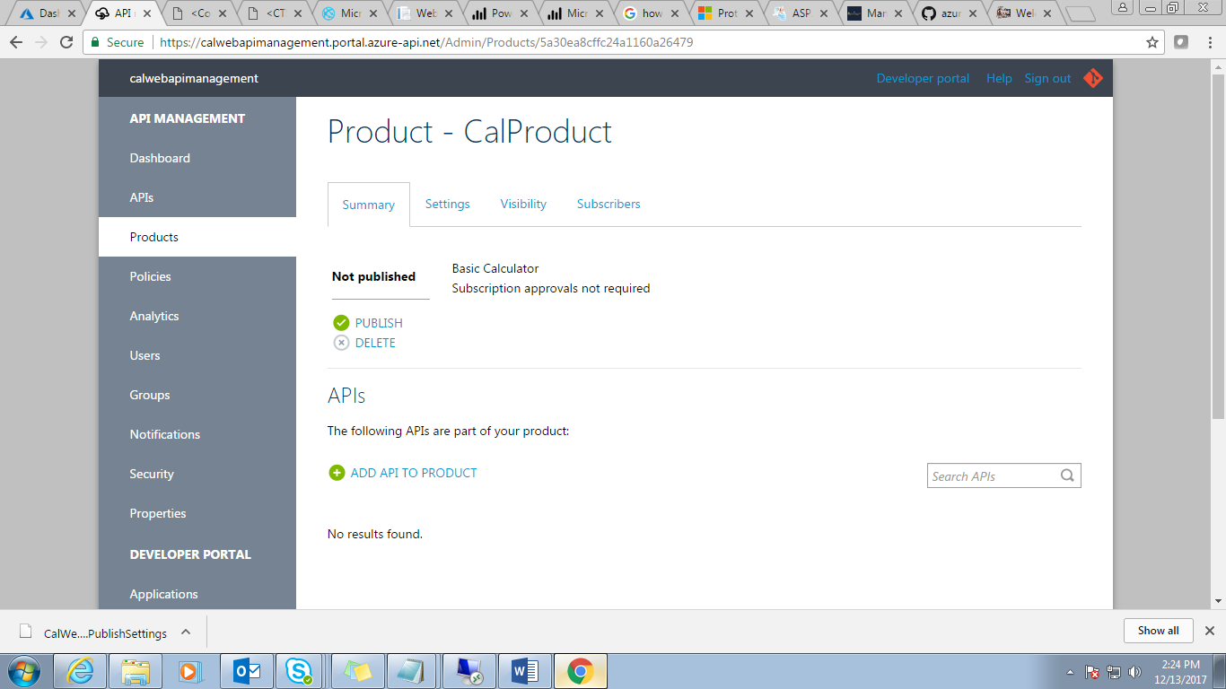

**Step 20:** Click on “***Visibility***” Tab.

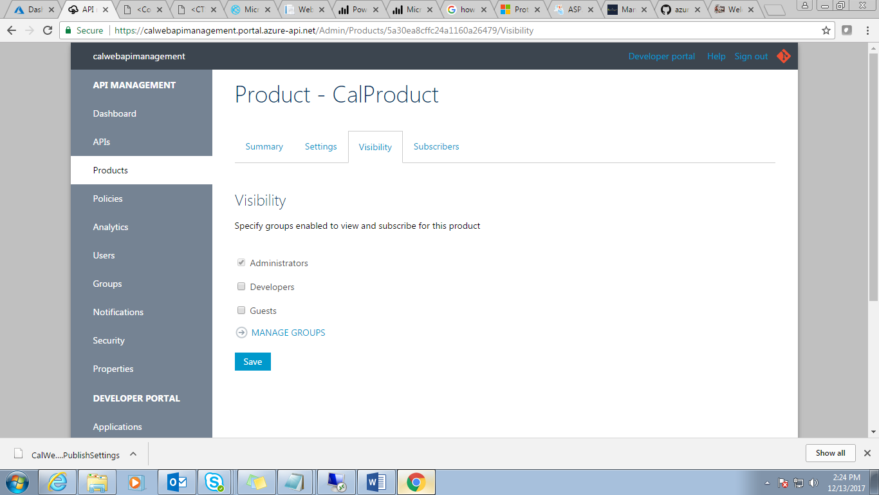

**Step 21**: Select the check box as per your requirement. I have selected all for testing purpose.

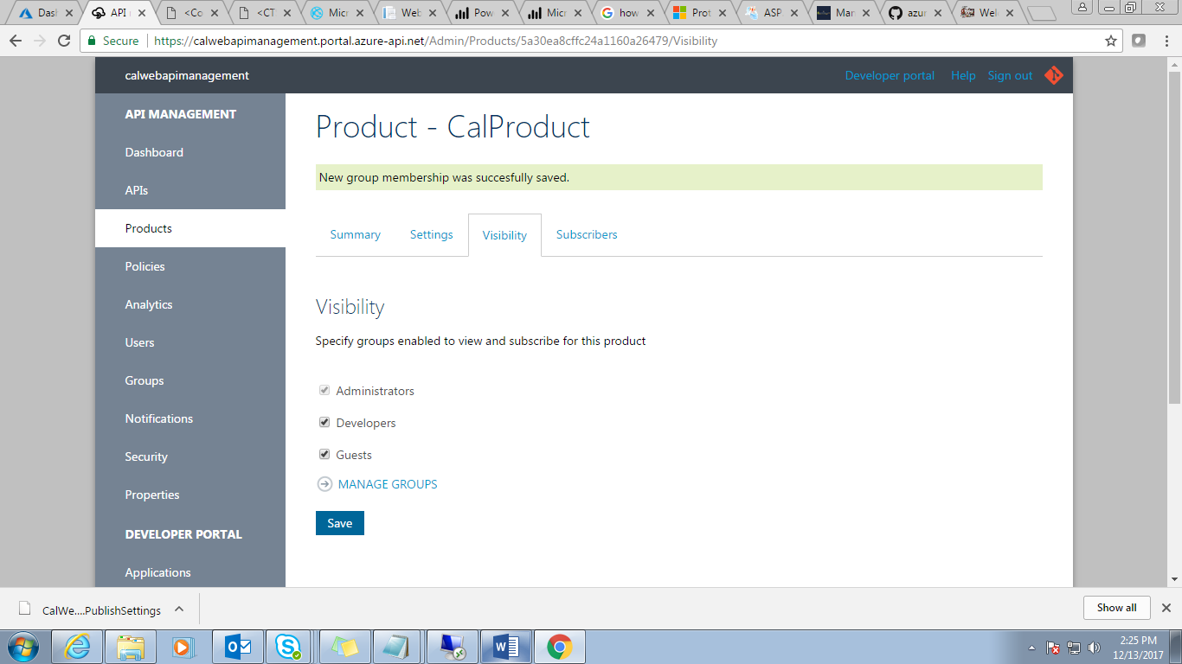

**Step 22:** Click on ***Save***.

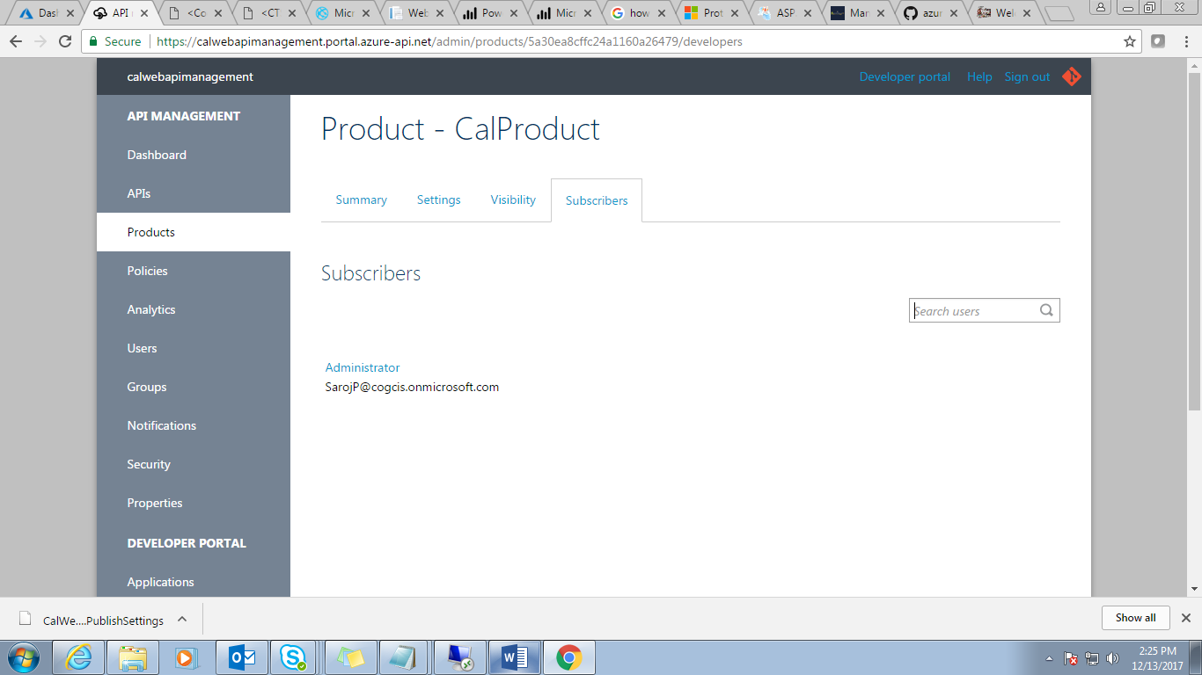

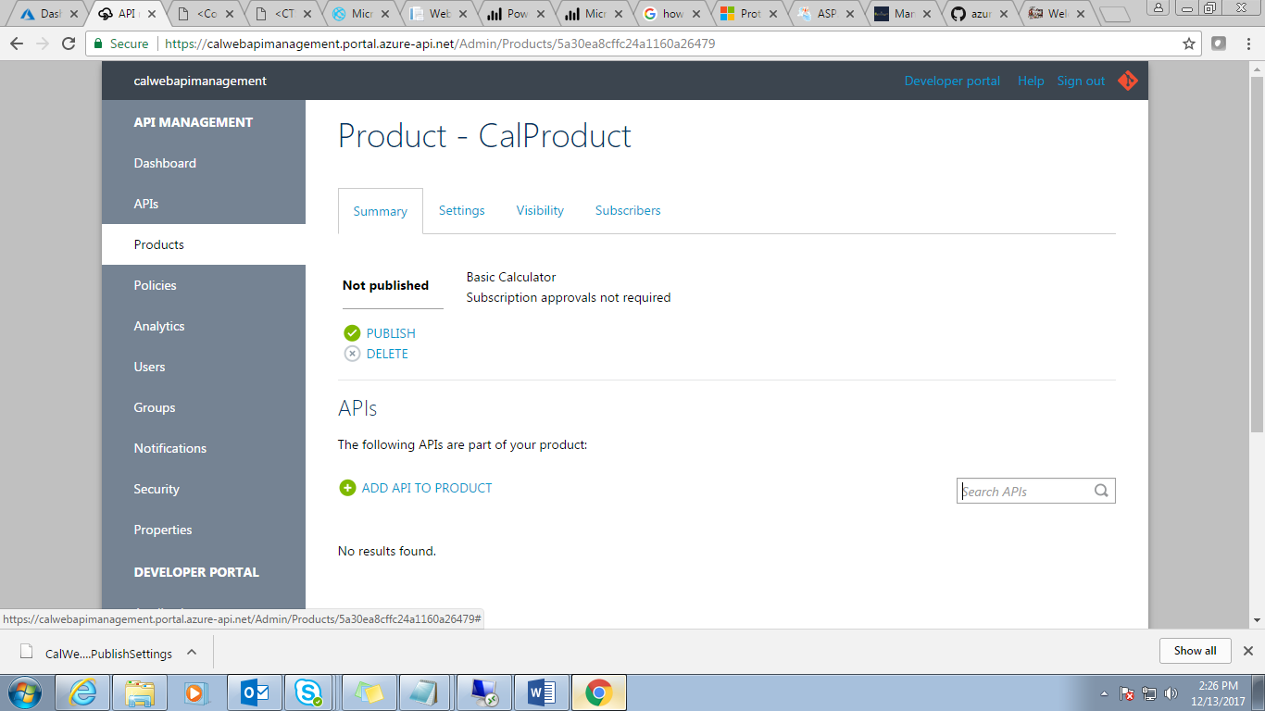

**Step 23:** Now click on “***ADD API TO PRODUCT***”.

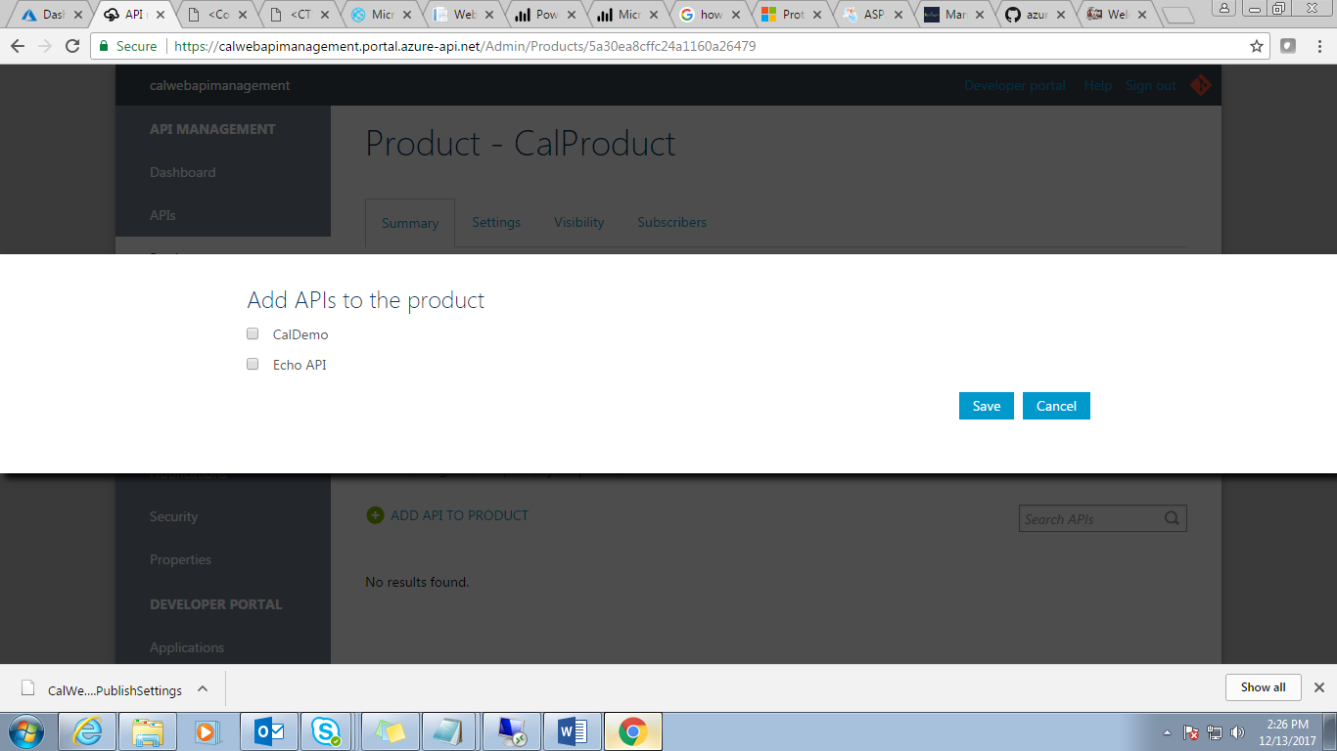

**Step 24:** Select your API “***CalDemo***” then ***Save***.

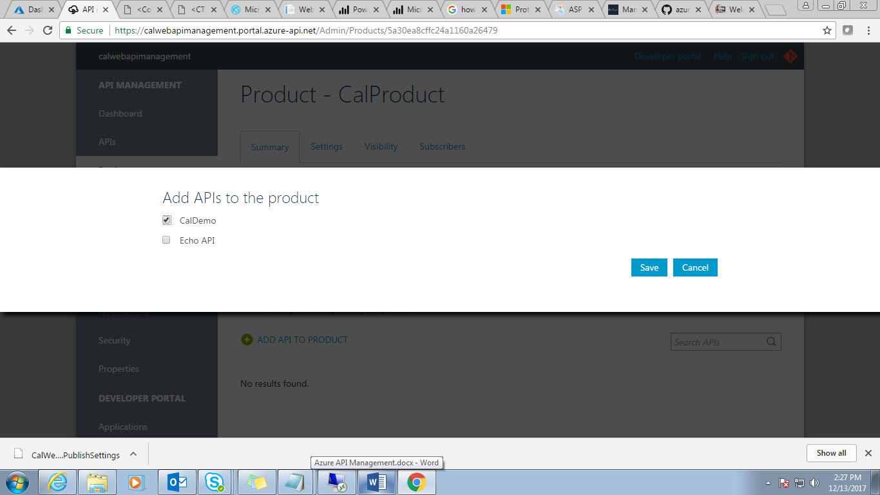

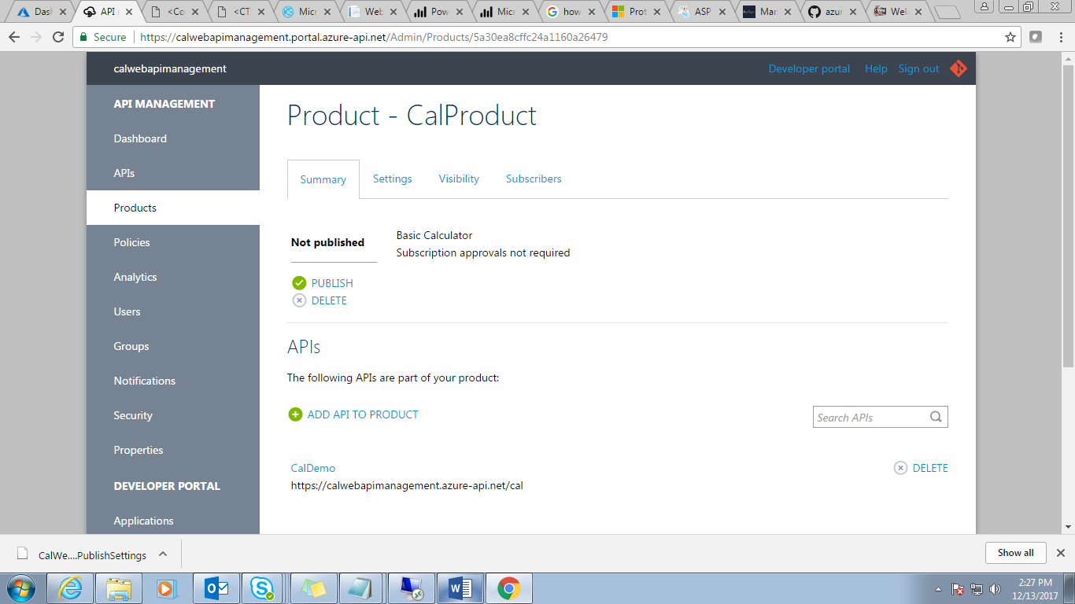

**Step 25:** Now ***Publish*** it.

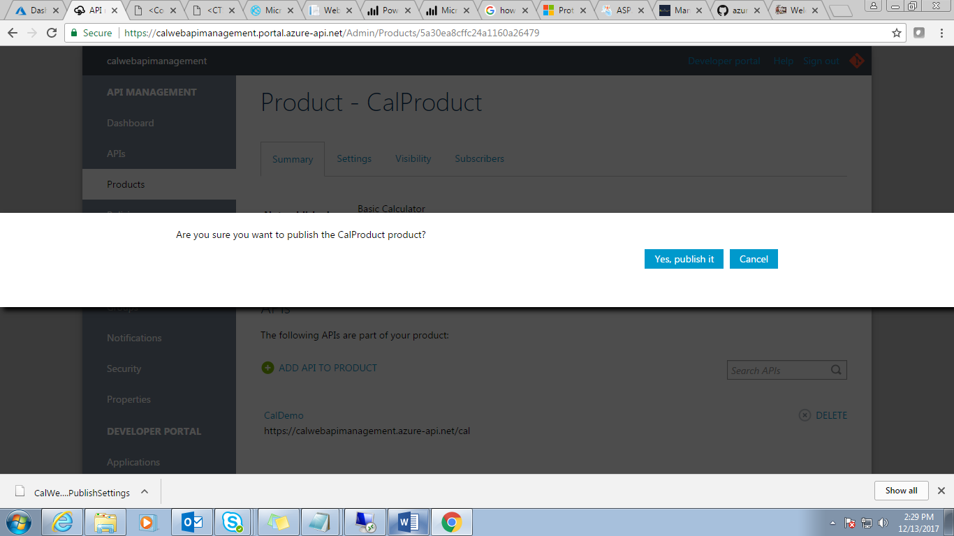

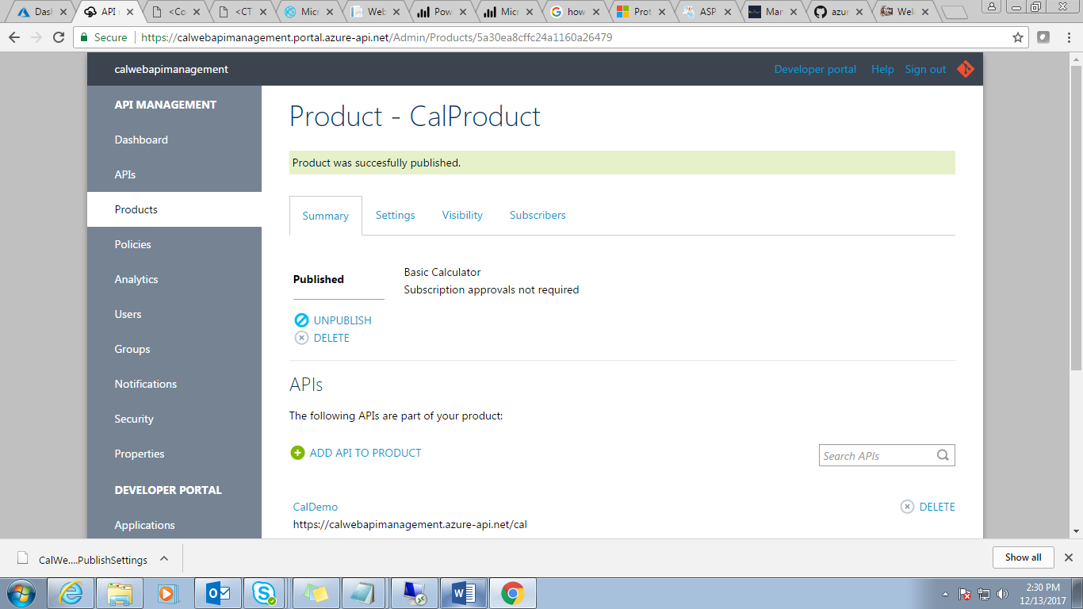

**Step 26:** Now click on “***CalDemo***” API and check Products

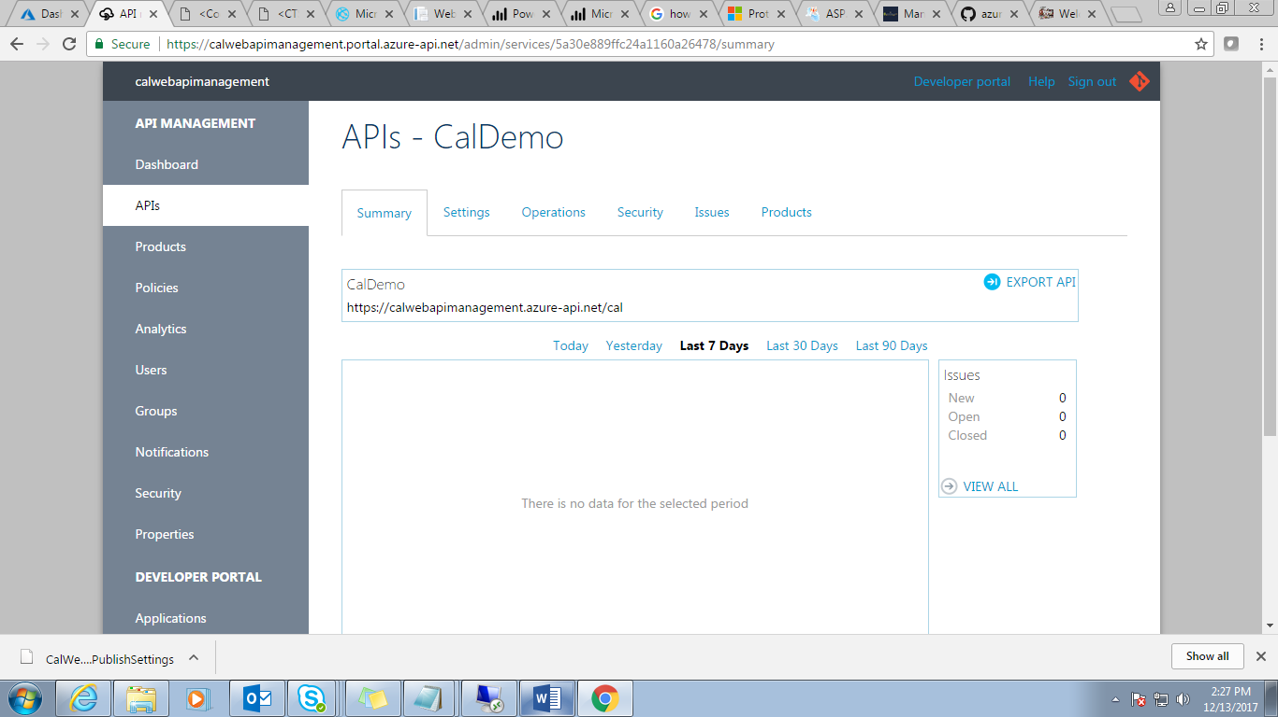

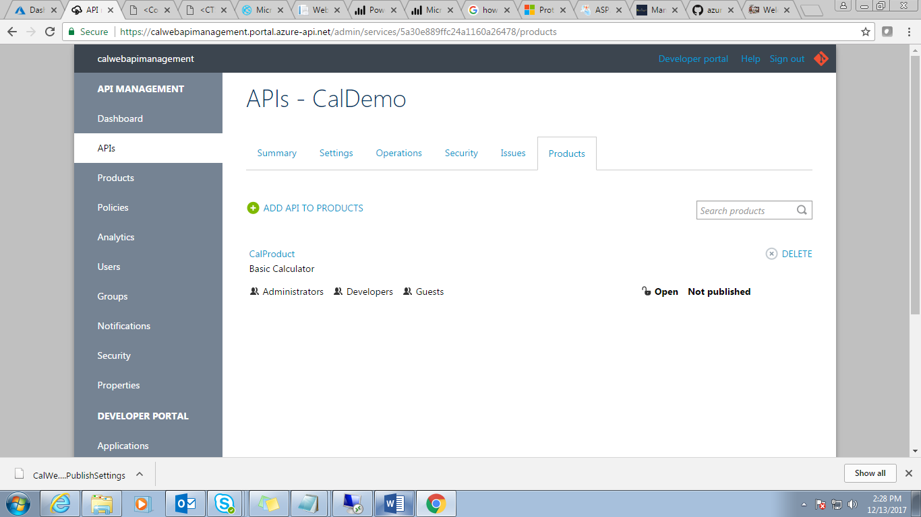

**Step 27:** Now go back to your Azure portal and click on “***Developer Portal***”.

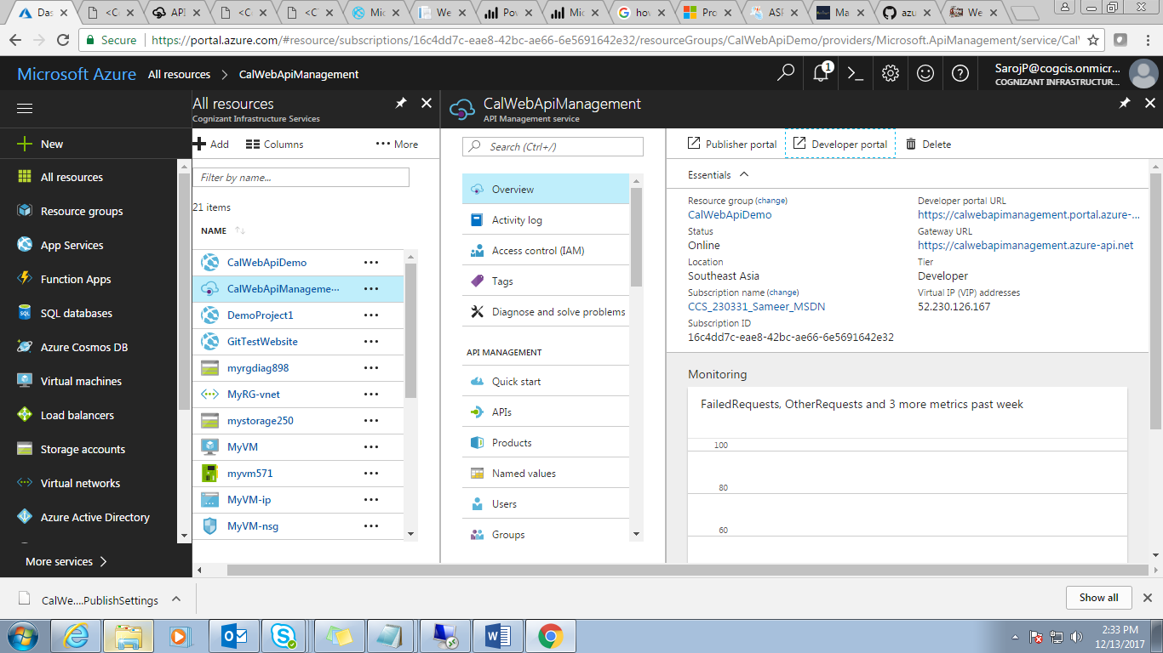

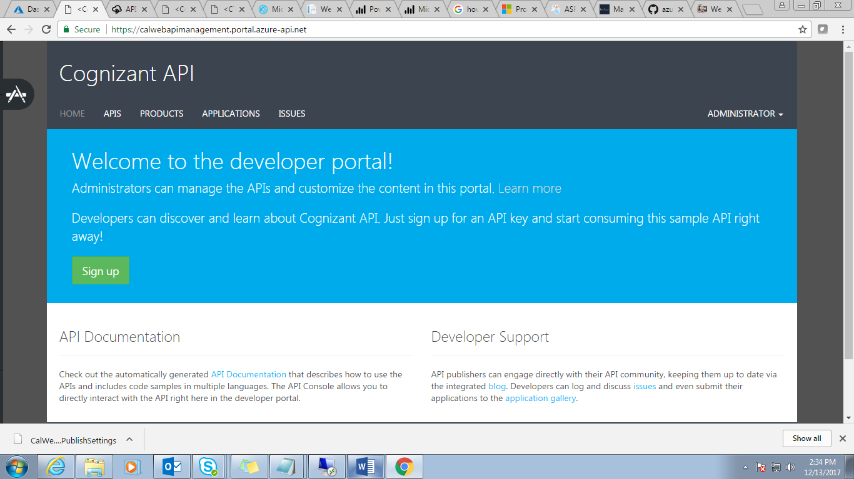

**Step 28:** Click on ***APIS.***

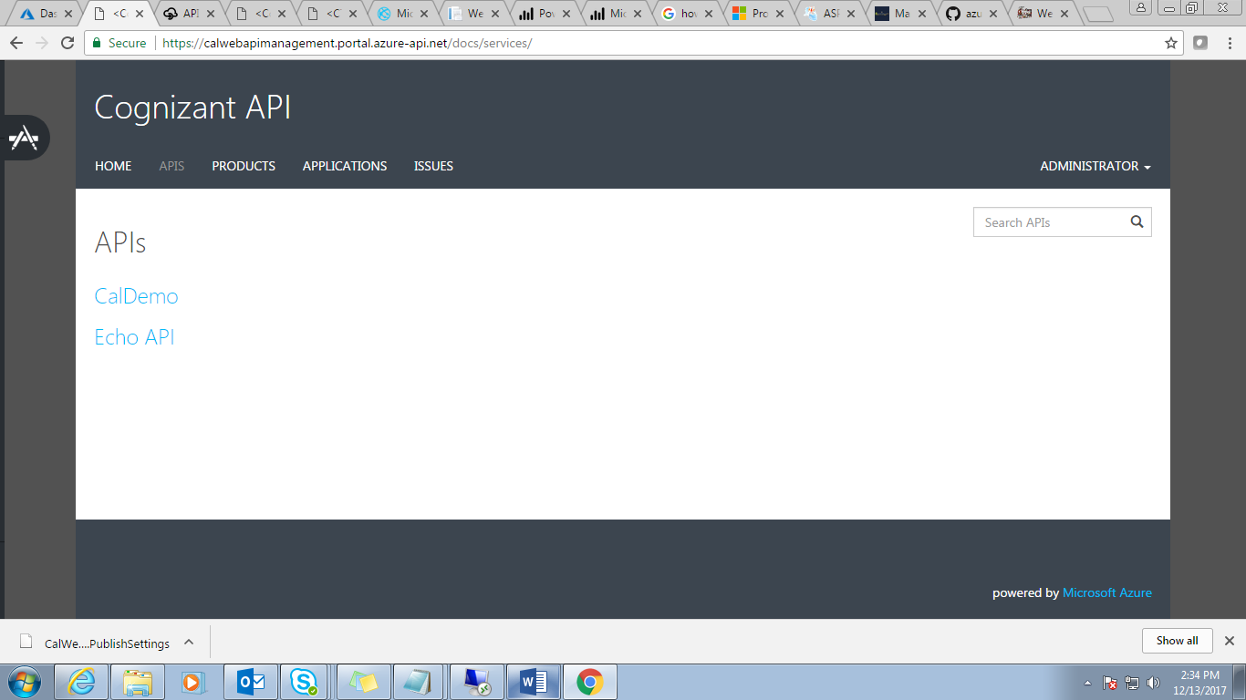

**Step 29:** Click on your API “***CalDemo***”.

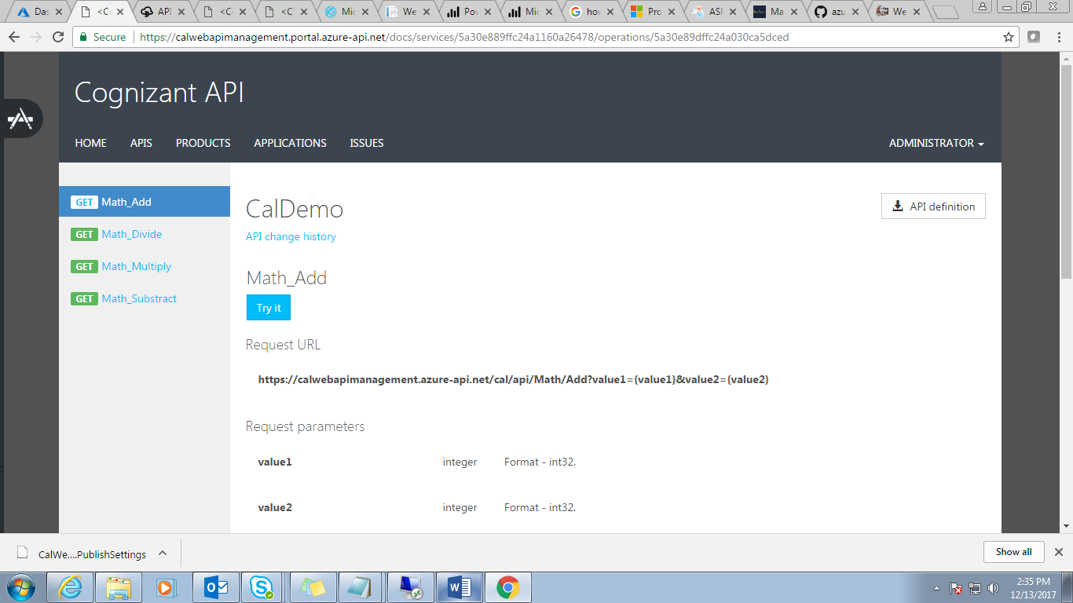

**Step 30:** Click on “***Try It***” for testing.

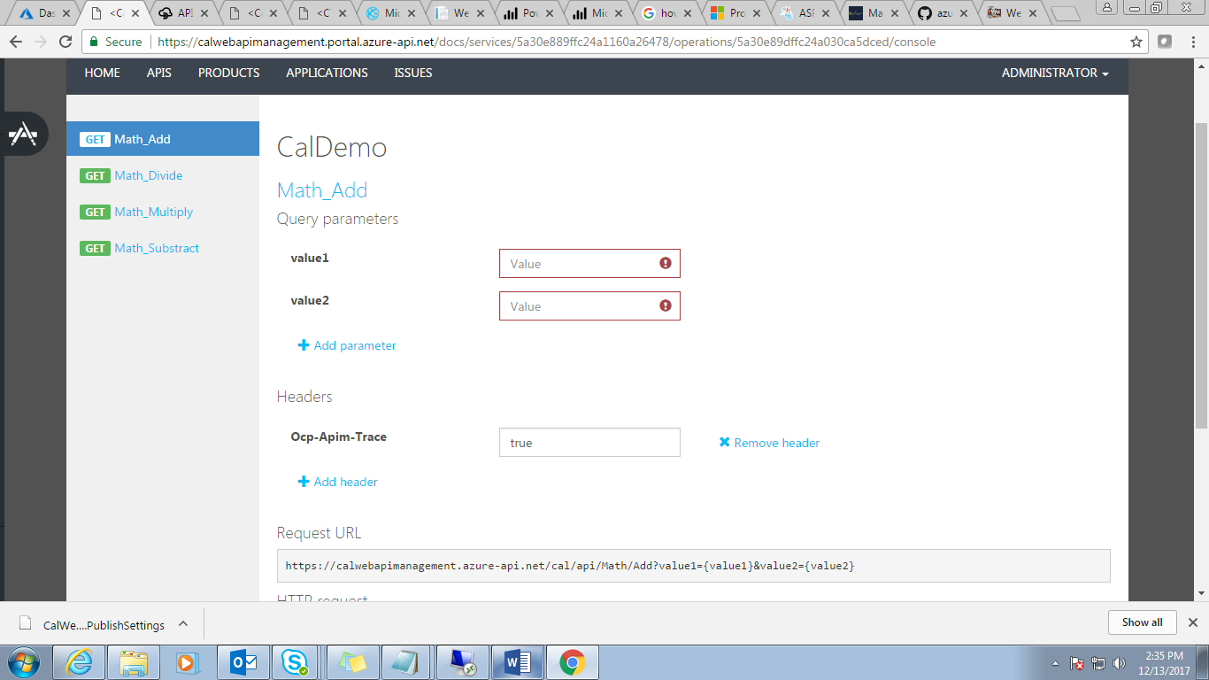

**Step 31:** Now your Azure Web API is ready to use.

1. **Use it in a client project.**

**Step 1:** Create a client application and use this Azure Web API.

Create an asp.net MVC project or you can use same application which is created for web API. Here I am using the same Project.

Open Home controller and use below code.

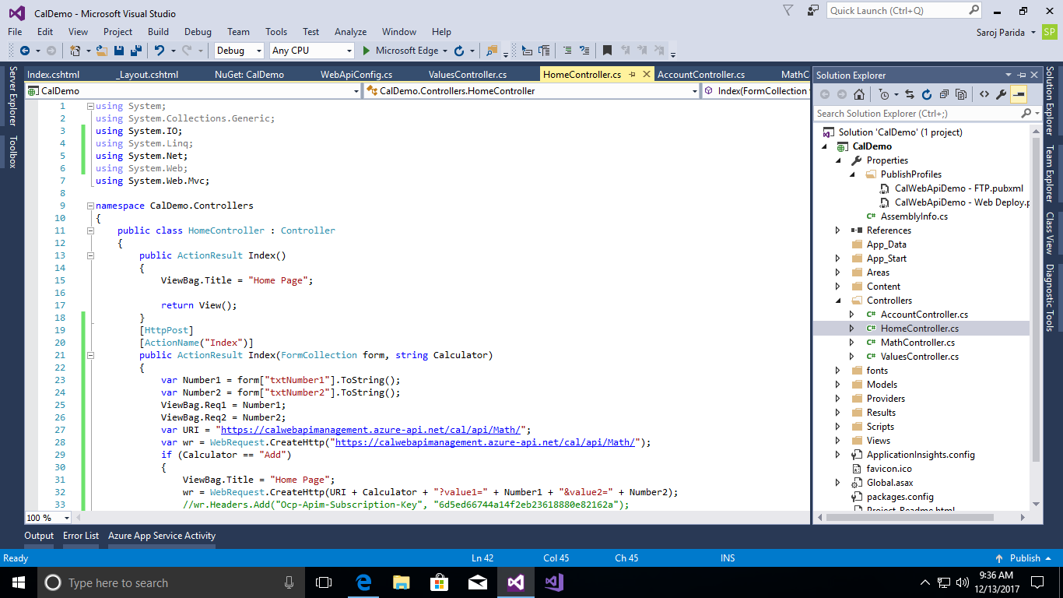

**Code:**

using System;

using System.Collections.Generic;

using System.IO;

using System.Linq;

using System.Net;

using System.Web;

using System.Web.Mvc;

namespace CalDemo.Controllers

{

public class HomeController : Controller

{

public ActionResult Index()

{

ViewBag.Title = "Home Page";

return View();

}

[HttpPost]

[ActionName("Index")]

public ActionResult Index(FormCollection form, string Calculator)

{

var Number1 = form["txtNumber1"].ToString();

var Number2 = form["txtNumber2"].ToString();

ViewBag.Req1 = Number1;

ViewBag.Req2 = Number2;

var URI = "https://calwebapimanagement.azure-api.net/cal/api/Math/";

var wr = WebRequest.CreateHttp("https://calwebapimanagement.azure-api.net/cal/api/Math/");

if (Calculator == "Add")

{

ViewBag.Title = "Home Page";

wr = WebRequest.CreateHttp(URI + Calculator + "?value1=" + Number1 + "&value2=" + Number2);

//wr.Headers.Add("Ocp-Apim-Subscription-Key", "6d5ed66744a14f2eb23618880e82162a");

using (var response = wr.GetResponse())

{

var html = new StreamReader(response.GetResponseStream()).ReadToEnd();

ViewBag.WebResponse = html;

}

}

if (Calculator == "Substract")

{

ViewBag.Title = "Home Page";

wr = WebRequest.CreateHttp(URI + Calculator + "?value1=" + Number1 + "&value2=" + Number2);

//wr.Headers.Add("Ocp-Apim-Subscription-Key", "6d5ed66744a14f2eb23618880e82162a");

using (var response = wr.GetResponse())

{

var html = new StreamReader(response.GetResponseStream()).ReadToEnd();

ViewBag.WebResponse = html;

}

}

if (Calculator == "Multiply")

{

ViewBag.Title = "Home Page";

wr = WebRequest.CreateHttp(URI + Calculator + "?value1=" + Number1 + "&value2=" + Number2);

//wr.Headers.Add("Ocp-Apim-Subscription-Key", "6d5ed66744a14f2eb23618880e82162a");

using (var response = wr.GetResponse())

{

var html = new StreamReader(response.GetResponseStream()).ReadToEnd();

ViewBag.WebResponse = html;

}

}

if (Calculator == "Divide")

{

ViewBag.Title = "Home Page";

wr = WebRequest.CreateHttp(URI + Calculator + "?value1=" + Number1 + "&value2=" + Number2);

//wr.Headers.Add("Ocp-Apim-Subscription-Key", "6d5ed66744a14f2eb23618880e82162a");

using (var response = wr.GetResponse())

{

var html = new StreamReader(response.GetResponseStream()).ReadToEnd();

ViewBag.WebResponse = html;

}

}

return View();

}

}

}

**Step 2:** Open ***Inex*** view and update with below code:

<div class="jumbotron">

<h1>Basic Calculator</h1>

@using (Html.BeginForm("Index", "Home", FormMethod.Post))

{

<table>

<tr>

<td>

Enter First Number

</td>

<td>

@Html.TextBox("txtNumber1", (string)ViewBag.Req1)

</td>

</tr>

<tr>

<td>

Enter Second Number

</td>

<td>

@Html.TextBox("txtNumber2", (string)ViewBag.Req2)

</td>

</tr>

<tr>

<td>

Result

</td>

<td>

@Html.TextBox("txtResult", (string)ViewBag.WebResponse, new { htmlAttributes = new { @readonly = "readonly" } })

</td>

</tr>

<tr><td><br /></td></tr>

<tr>

<td colspan="2" align="right">

<input id="btnAdd" onclick="return isInteger()" type="submit" name="Calculator" value="Add" />

<input id="btnSubstract" onclick="return isInteger()" type="submit" name="Calculator" value="Substract" />

<input id="btnMultiply" onclick="return isInteger()" type="submit" name="Calculator" value="Multiply" />

<input id="btnDivide" onclick="return isInteger()" type="submit" name="Calculator" value="Divide" />

</td>

</tr>

</table>

}

</div>

<script type="text/javascript">

function isInteger() {

var returnval = false;

input1 = document.getElementById('txtNumber1').value;

input2 = document.getElementById('txtNumber2').value;

if (Number.isInteger(+input1) && Number.isInteger(+input2)) {

returnval = true;

}

else {

alert('Please Enter valid integer value.')

}

return returnval;

}

</script>

**Step 3:** Now you can run the application (F5)

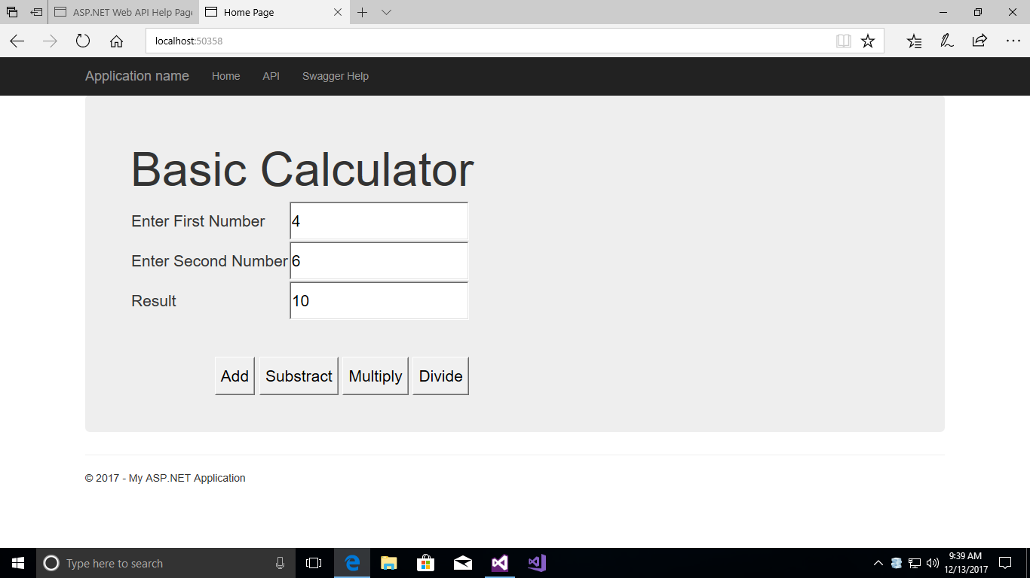

**Step 4:** Here you can check the operation whether it is working fine or not.

Now you can deploy same in Azure for remotely accessible. Please follow same procedure Azure deployment, we did last time for ***Web API*** deployment.

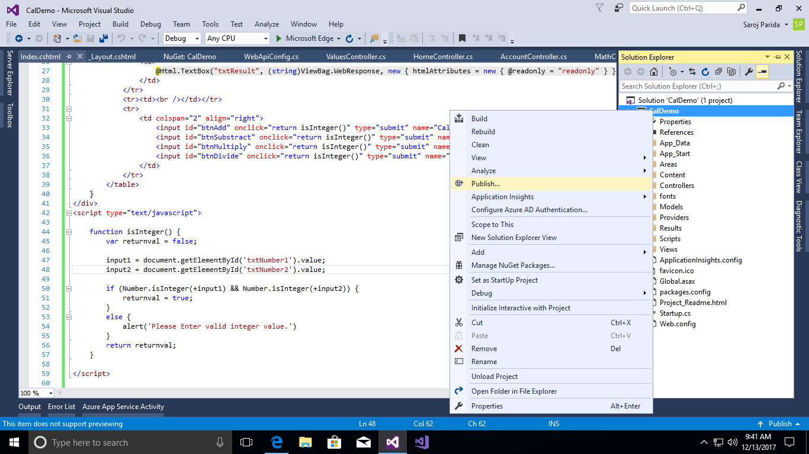

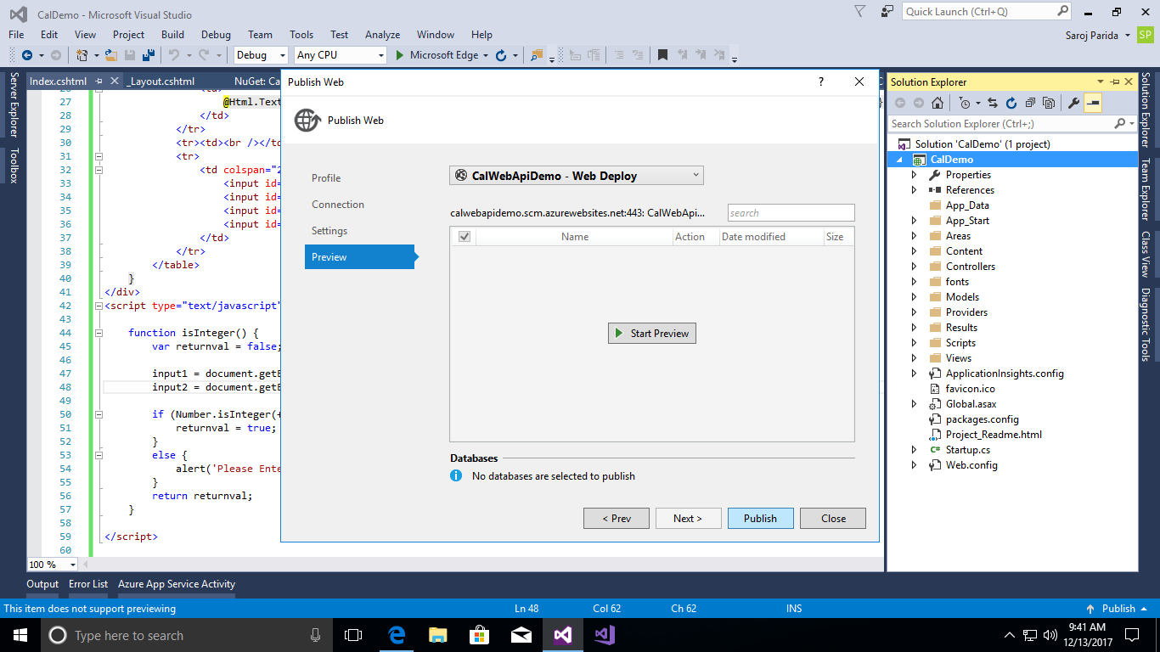

**Step 5:** Click on ***Publish.***

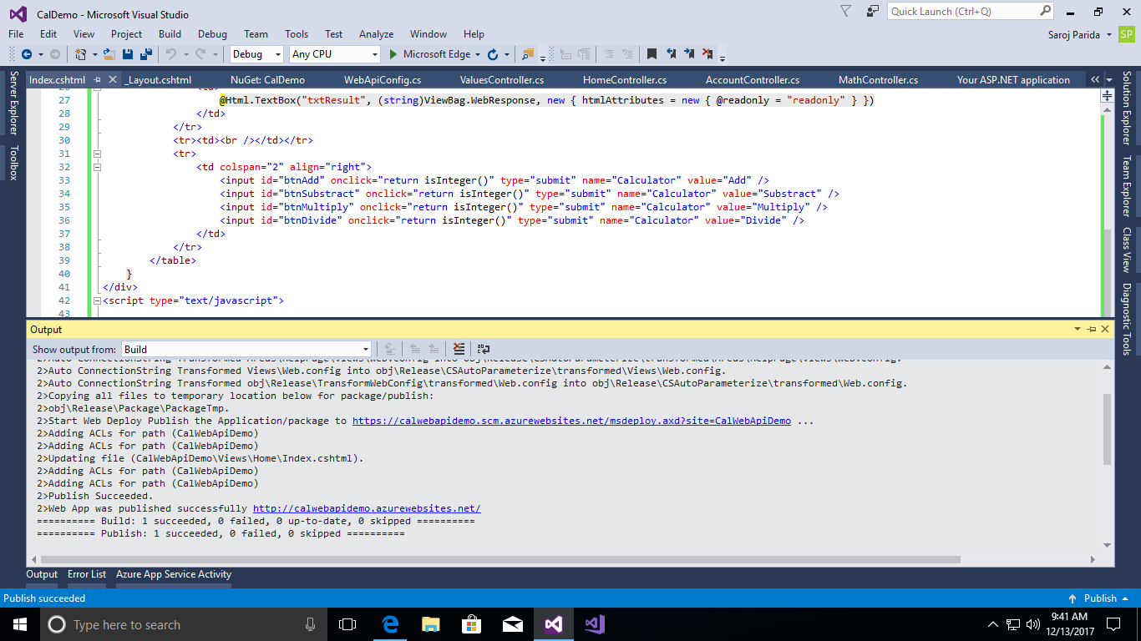

**Step 6:** It will automatically redirect to your azure ***url.***

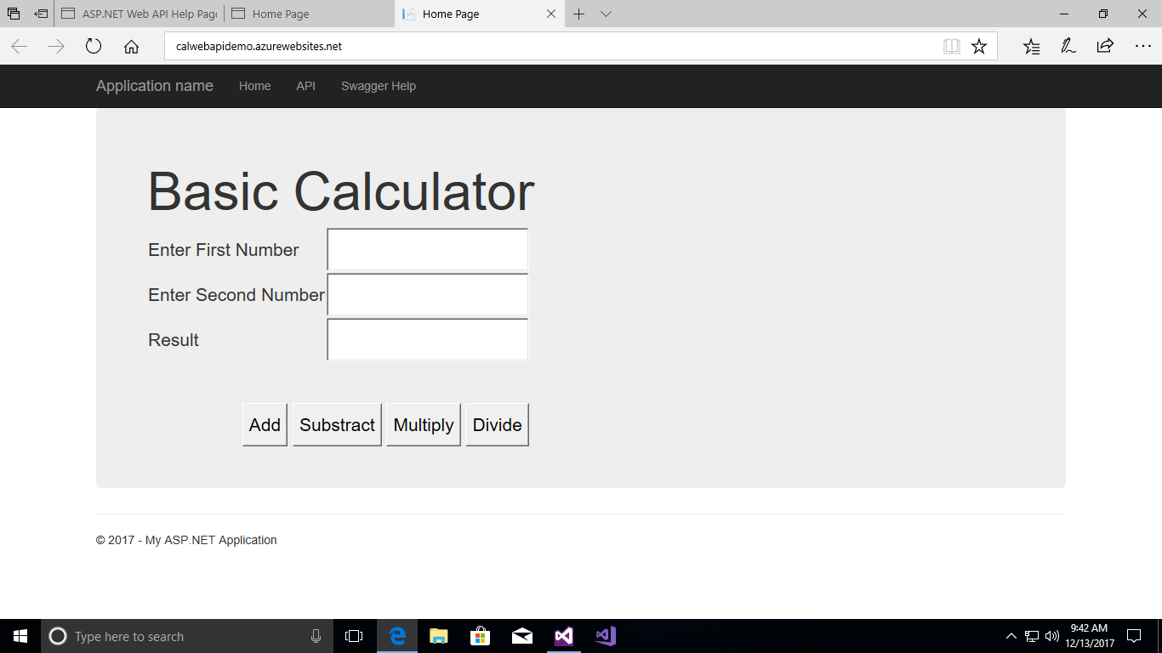

**Step 7:** Now your client application is ready where using the Web API with Azure Web API Management.

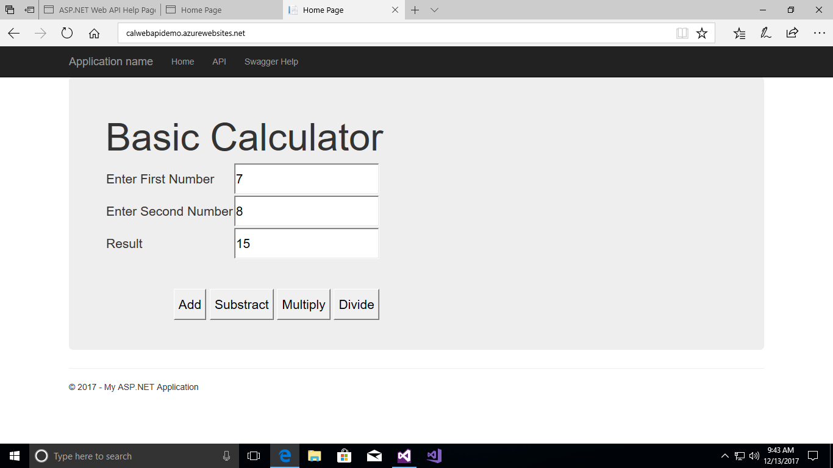

The application has been deployed successfully in the Azure cloud. Now you can use below link for use Basic Calculator.

**URL:** <http://calwebapidemo.azurewebsites.net/>